 Lea Endowed C.E Primary School PE Uniform
PE UNIFORM | ACCEPTABLE | UNACCEPTABLE
Plain white t-shirt | 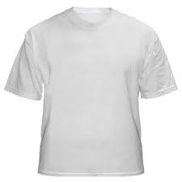   | 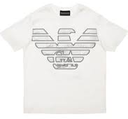
Plain navy or black shorts/skort | 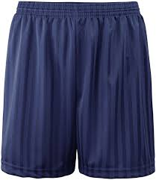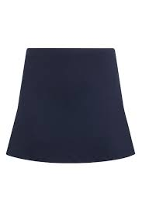 | NO cycling shorts  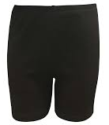
Plain black plimsolls/pumps for indoor PE. | 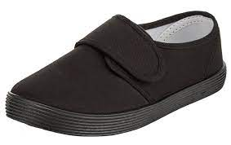 | 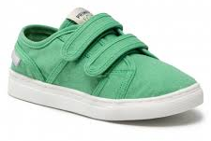
Plain navy or black jogging bottoms | 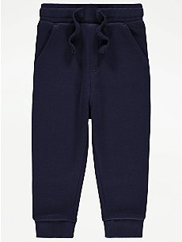 | 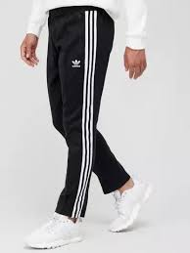
Plain navy or black zipped hoodie  Zipped hoodies with the school logo can be purchased from Top One Uniform, St Johns Shopping Centre or Bang, Bang, Lancaster Road, Preston. | 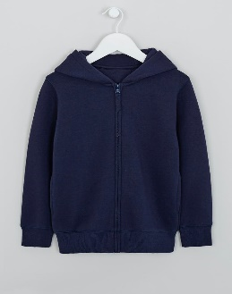 | 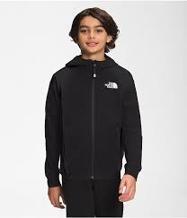
Plain black or navy trainers.  Self-coloured or subtle logos only please. | 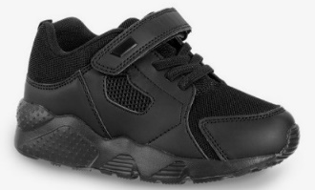 | NO bright colours and designs  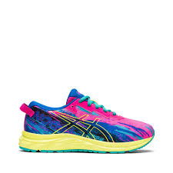
NO Earrings or jewellery | For Health and Safety your child is not permitted to wear earrings. Please remove them at home on PE day before coming to school. | 