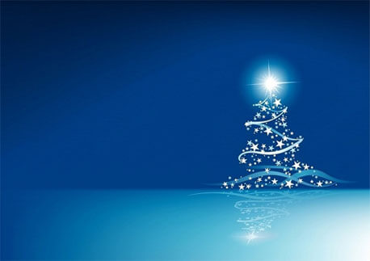
Autumn 2 – Round Up – Class 3

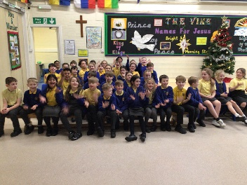
It’s hard to believe that our first term has already come to an end! Over the past term, the children have thoroughly enjoyed using Fantastic Mr Fox as our class text. They not only read the story with enthusiasm but also created their writing from it – I am sure Roald Dahl would have approved. The children went on to make some super clay models of Mr Fox or Badger as part of their Art. The children also wrote some lovely play-scripts using a short film, Soar, as their inspiration.
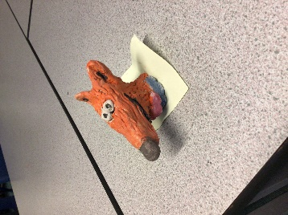
In Maths, we’ve concentrated on multiplication and division. This led to some exciting and highly competitive battles, with the children achieving some fantastic scores! Regular practice on TTRS is proving invaluable, and I hope the children continue to use this resource frequently. Please remember that Year 4 pupils will complete the statutory Multiplication Check in the summer term, so fluency with all facts up to 12 × 12 is essential. Multiplication underpins so many areas of Maths, including fractions, money, and area so it is really worth spending the time on this.
Science has been all about States Of Matter this half term. Class 3 explored how a solid can turn to a liquid and how a liquid can turn into a gas. We explored the water cycle and conducted some investigations so that we could see the cycle in action in our classroom! This term, the children have been learning how to be a ‘scientist’, using equipment carefully and accurately and recording results in a variety of ways.
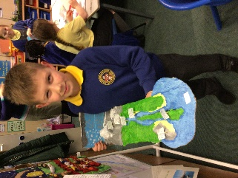
Our History topic on the Tudors in half term 1 was a big hit! The children learned about the Tudor homes and the homework projects were phenomenal! We built a Tudor street which the children ‘travelled along’ to explore what life must have been like. We also looked at Henry VIII and his poor behaviour and also the reign of Elizabeth the First. We wrote fact files when we had conducted our research.
We learned all about David in our RE during half term 1, charting his rise from humble shepherd boy to a King. This half term, we have really enjoyed finding out why Jesus is described as the Light of the World. We did some beautiful writing and artwork to demonstrate our understanding of this.
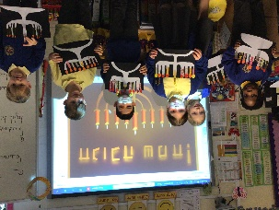
This term has also been packed with special events: the Book Fair, our Year 6-led Remembrance Service, Odd Socks Day celebrating individuality, a visit from the Life Bus, the Puss-in Boots pantomime, and our joy filled Christmas production, The Guiding Light of Christmas. We hope you all enjoyed watching it as much as we enjoyed performing it for you.
School life is always busy, and I want to thank you for your continued support—it truly makes a difference.
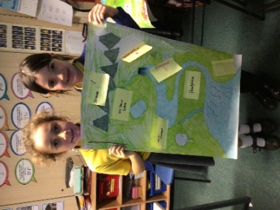
Finally, I’d like to wish you and your families a joyful, peaceful Christmas. I look forward to seeing everyone in 2026.
Merry Christmas from Mrs Bolton, Miss Wilson, Mrs Southword, Mrs Morris,
Mrs Salisbury and Mrs Walton

