Maths  This week the focus for our maths learning is Multiplication and Division. There are lots of wonderful resources on the White Rose Maths Hub for you to access for your child to support Home Learning.  Please access via the link below and select Autumn Week 12 to select teaching videos.  https://whiterosemaths.com/homelearning/year-2/week-12-number-multiplication-division/  Related worksheets and activities can be found on our home learning page. Complete one video and the related activity every day – Sessions 1, 2 & 3 this week please.  Extra Miler Activities for our Year 2 “Math Professors”  Additional Math activities to support your child’s learning can be found on the BBC Bitesize website.  Select the Karate Cats Maths game.  Choose Multiplication and Division as the topic and work your way through Bronze, Silver and Gold levels of the game. Have fun!  https://www.bbc.co.uk/bitesize/topics/zjkphbk/articles/zf4sscw  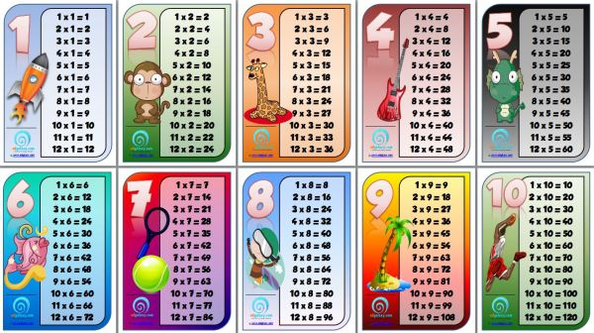 |  | 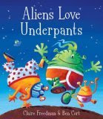  English – Claire Freedman  This week we are looking at the story ‘Aliens love Underpants’ by Claire  Freedman. You can view and share the story via the following link.  https://www.youtube.com/watch?v=hycPZ2jtmhQ  - Can you spot any words that end with _ed or _ing in the story? Make a list.  - Choose your favourite alien and draw a picture. Label your picture with noun phrases eg. Big, red pants, Stripy, green skin…  - Write four questions you would like to ask your alien. Remember your question marks.  - Write a character description for your alien. Include what they look like and describe their personality.  Please remember to view any link you use before sharing with your child and ensure your child stays on that page only. Stay safe online.  Reading – Read daily via the Oxford Owls website using our class login.  https://www.oxfordowl.co.uk/  Go to the Oxford Owl for Schools and click on login.  Students section.  Username: leaclass2  Password: dragon  Choose 4-7 years, click in reading levels and scroll down to select your child’s book band colour and choose a book to read.  Spelling, Punctuation and Grammar (SPAG)  https://www.bbc.co.uk/bitesize/topics/zd63xyc/articles/zdp4pg8  Login to the Karate Cats English game on the BBC Bitesize website and practice your grammar, punctuation and spelling using these fun games. Can you get your WHITE belt this week?  When you have gained your WHITE belt select ‘Freeplay’ and choose from the Grammar, Punctuation or Spelling sections  Let me know what you think - I had great fun playing them!!!  Remember to practice your Year 2 spellings and common exception words. A copy of the spellings overview for each week this half term have been added to the website for you.
Frosty Fingers  Investigate what happens when you leave an ice cube or an ice-lolly on a plate.  Explore and see what happens if you put them in different places around the house. Write about what you discovered. Where is the worse place to put it?  Year 2 Challenge: Make your own ice-lolly using fruit juice or flavoured milk. Write a recipe to share with a friend. | Snowflakes  How many different snowflake patterns can you make?  Try using different shaped pieces of paper. | Do you wanna build a Snowman?  Construct a snowman using cotton wool or other items you find at home?  How many different materials can you use?  Which materials made the best snowman? Why?  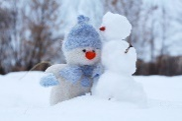 | New Year’s Resolution  Make a poster of your New Year’s resolution.  Are your New Year resolutions the same as anyone else in your family?  Year 2 Challenge: What new skill would you like to master this year?
Instruction writing  Write a set of instructions for something you have made this week at home.  Eg. Snowflakes, Collage, Snowman model, Baking  Year 2  Remember to Include a ‘what you will need’ list, numbered sentences and bossy verbs (command words) at the start of your sentences. Eg. Get, Cut, Mix | Winter Walk  Go on a walk and collect natural materials/objects to make a collage picture or make a sculpture outside and take a photograph.  Send it in – we’d love to see your creations! | My Favourite Christmas Present  What did Santa bring you?  Draw a picture of your favourite Christmas present, label special features and write a paragraph about why you like it so much.  (5-10 sentences) | Little Snowflake  Listen to the song Little Snowflake by Super Simple Songs  https://www.youtube.com/watch?v=tbbKjDjMDok  Can you sing along and make a snowflake dance?  Write a list of as many words as you can to describe a snowflake.  Y2 Challenge: Write a poem about snowflakes falling using your words.

Workout of the Week – SPELL OUT YOUR NAME!
Using all the letters of your name (no cheating – must be your FULL first name and surname!) complete the workout doing the exercises at the side of each letter with the specified number of repetitions. Try to do it as quickly as possible, with as little rest as you need, BUT be careful not to get too excited and hurt yourself or others. Remember to warm up before you start and cool down at the end.
Do it each day and try to beat your time. Challenge your family to do their name exercises as well. Enjoy!!!
Had fun with this? Why not make up your own SPELL OUT YOUR NAME exercise challenge?
A : 10 HOPS | N: 10 BUNNY HOPS
B : 10 BUNNY HOPS | O: 20 HOPS
C: 10 SKIPS | P: 15 STAR JUMPS
D: 15 STAR JUMPS | Q: COMMANDO CRAWL FOR 10 SECS
E: 5 TUCK JUMPS | R: 10 SKIPS
F: MARCH ON THE SPOT FOR 30 SECS | S: BALANCE A TEDDY ON YOUR RAISED KNEE FOR 10 SECS
G: DO A SILLY DANCE FOR 30 SECS – CHALLENGE MUM! | T: 10 TUCK JUMPS
H: RUN ON THE SPOT FOR 10 SECS | U: BOUNCE A BALL FOR 15 TIMES
I: BOUNCE A BALL 10 TIMES | V: JOG ON THE SPOT FOR 30 SECS
J: BALANCE A TEDDY ON YOUR HEAD (20 SECS) | W: BALANCE ON EACH FOOT FOR 10 SECS
K: BALANCE ON 1 FOOT FOR 10 SECS | X: 15 STAR JUMPS
L: HOP, SKIP AND JUMP 3 TIMES | Y: DO A SILLY DANCE FOR 30 SECS – CHALLENGE DAD!
M: MOVE LIKE YOUR FAVOURITE ANIMAL FOR 30 SECS | Z: 5 TUCK JUMPS

