Summer Home Learning Activities
Moving on Up

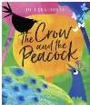  Reading for Fun  Read this new fable called The Crow and the Peacock (You may need an adult to sign up).  https://www.lovereading4kids.co.uk/book/17081/The  -Crow-and-the-Peacock-by-Johanna-Fernihough.html  It is also available on YouTube  https://www.youtube.com/watch?time_continue=42& v=nTvz_MrAPpg&feature=emb_title  Can you decide which bird you would like to be from the fable? Draw a picture of your bird and write a sentence about why you would like to be this one. | Self Portrait  Can you create a self-portrait for your new teacher? Remember to use a mirror and look carefully at your face when you are producing your picture.  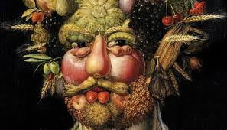  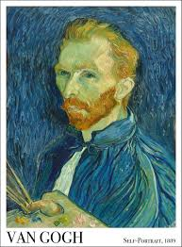  Perhaps after drawing a self-portrait you can try an unusual style such as Arcimboldo who uses fruit and vegetables. | Friend Fact File  Who are your friends in school?  Draw a picture of each friend and write about why you like them.  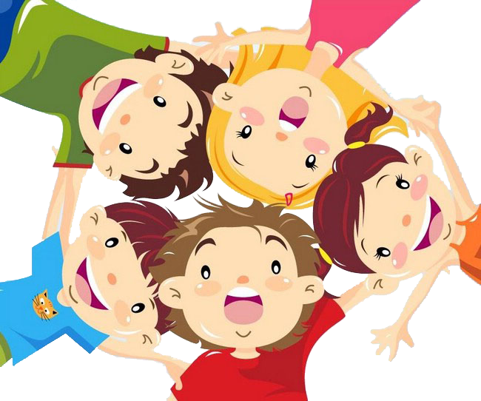  This Photo by Unknown Author is licensed under CC BY-NC
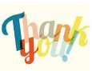  Thank You  Can you make a thank you card for your grown ups at home?  Tell your grown up what you have enjoyed the most when you have been learning at home. Can you remember what your best moment in your home learning? What will you miss when you come back to school in September? | 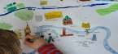  Map Your Way  Draw a map of things you see on your way to school. Are there any important buildings that you pass? Do you see any interesting things on houses like an outside clock or a fancy gate? | 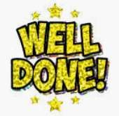  Celebrations  What things have you celebrated this year? Draw a picture and write a sentence about a celebration you have had. You may have celebrated your birthday, learnt to ride your bike, lost some baby teeth or learnt a new skill.

Favourite Book Review  What is your favourite book or story? It might be a book that is read by your grown-ups or one you can read by yourself.  Can you draw a picture of your favourite part from the story? Can you list all the characters?  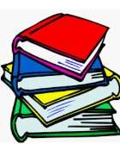  Can you create a new front cover for the story? Talk to an adult about the changes you have made to the front cover. | Things to be proud of  Can you write a list of all the things you can do that you are proud of?  Maybe you have learnt to ride your bike without stabilisers or can read a book without any help now. You could make your own medal and write on it what you are proud of. | Worries  You might be worried about starting in Year 1, but you shouldn’t let these worries bother you.  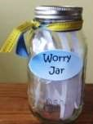  Make sure you tell someone about your worry. You could also write your worry down and pop it into a worry jar.  Have a look at the book ‘The Very  Hungry Worry Monsters’ here  on Youtube  https://www.youtube.com/watch?v=HJYMcEgTMmY
10 Things in a Teacher's Pocket  Ian Mcmillan wrote a poem called "10 Things Found in a Wizard's Pocket".  https://www.youtube.com/watch?v=RetmgAo2CvM  Can you think of 10 things you might find in a teacher’s pocket?  Draw a picture of your 10 items and label them  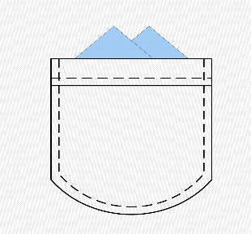  This Photo by Unknown Author is licensed under CC BY-SA | Marvellous Me  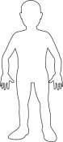  Draw around yourself in chalk on the floor or on a large piece of paper.  Can you write down all the lovely things that make you marvellous inside your outline? | Class Rules  Can you think of the rules you might have in Year 1? Can you write a list of rules for next year to help you learn?  You can make your paper look old by using a piece of white paper and placing an old, cold teabag all over it. This will make your paper look old like parchment.
Summer Treats  The summer is always a time where you can find tasty, fresh fruits in the shop. Can you try and taste some new fruits?  Carry out a taste test and decide if you like the fruit? Why do you like or not like the fruit? Would you have it again?  Perhaps you can tell a friend or family member about a new piece of fruit you have tried.  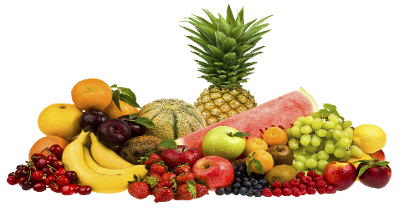  This Photo by Unknown Author is licensed under CC BY-NC | Tennis Tournament  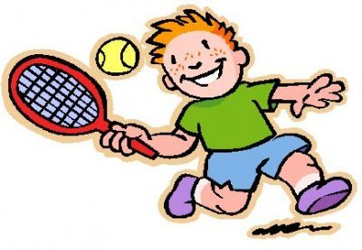  Wimbledon is normally held during the months of June and July. Can you practice hitting a tennis ball with a bat and carry out a small tennis tournament at home? You could count how many times you hit the ball without it dropping and keep a score of who has more hits.  This Photo by Unknown Author is licensed under CC BY-SA-NC  Have a look at the Wimbledon trophy and see if you can use junk model materials to make your own trophy. Can you carry out a trophy presentation to the winner of the tournament? | Design an Island  This summer we might not be going on holiday and we might be staying at home instead.  Can you design your own holiday island that you would like to visit? Can you draw a picture or make a model of your island and add labels?  Will your island be warm or cold?  What plants will grow on your island?  Will there be fruits growing on your island or not?  Will there be animals on your island? Are they friendly animals or not?
Reach for the Stars  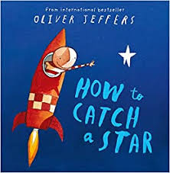  Watch the story ‘How to Catch a Star’ by Oliver Jeffers. https://www.youtube.com/watch?v=rpyR6hJPxiw  Think about all the times you have found something hard and wanted to give up. Think about all the things you have not managed to do yet but want to be able to complete.  Can you choose one thing that you wish to be able to do by the end of Year 1? You could write this out in a star outline and place someone at home that you can look at to remind you of your goal. | Butterflies  Can you find out some facts about butterflies? Write down your 3 favourite facts.  Have a go at this Science Experiment from Twinkl. Can you make your butterfly balance on your finger? | Penny chemistry  Clean some old pennies using ketchup. Why does ketchup get them so clean?  Check out the science behind it here  https://bit.ly/3ea4DBD  