Hi Year 6; I am hoping that this will be your very last week of Home Learning! Next week, we will be back in our own classroom with our friends and adults, learning face to face. I can hardly remember what that is like! So, please work hard this week, so that next week we can celebrate all your achievements together1

Shine brightly, Mrs Bolton

|  |  |  |  |
| --- | --- | --- | --- |
| **English** | **Littleshoemaker - THE LITERACY SHEDFocus - The Little Shoemaker**  In a timeless Parisien street there is a little shoemaker called Mr Botte. He makes and sells a special kind of shoes and business is good. However, the little shoemaker's life is about to change... a new shoe seller is in town and he will do anything to gain business. Mr Botte's business starts to fail. How will he cope? Maybe he will get some help from unexpected quarters…  **Watch the short animation of the story -**  [**https://www.literacyshed.com/littleshoemaker.html**](https://www.literacyshed.com/littleshoemaker.html)   * **Monday –** Describe both Mr Botte and the rival shoemaker using vivid and rich language choices. Split your page in half and write about Mr Botte on one half of your page and the rival shoemaker on the other. Think about character and personality as well as exterior features. Use your imagination to ‘fill in the gaps’ – there is no speech in this animation so you can determine for yourself about some character traits using movement and colour to help you decide! * **Tuesday -** Create some dialogue between the two characters – you could do this in two different ways.   **Either**: Create a play-script type piece of work, using the two characters, with stage directions for movement and gesture. Remember that you don’t need speech marks in a play-script; you simply write the character’s name, then stage directions in brackets, followed by a colon and then  the words that each character is saying. This is an example –  **Mr Botte** (hand on his work bench and other hand on hip): I cannot compete with his new-fangled designs.  Please note - You need to start a new line each time a different character is speaking.  **Or:**  You can draw Mr Botte on the left side of your page and the rival shoemaker on the right of your page followed by speech bubbles, detailing the characters’ conversation. Remember, you do not use speech marks when writing dialogue in a speech bubble. Here is a simple example of what you might do on the right:   * **Wednesday and Thursday –** Retell the story of The Little Shoemaker in a fairy tale style. How do fairy tales begin? Remember there is always a protagonist and an antagonist and there is normally a happy ending (there is on the animation too so stick closely to the storyline). Write in paragraphs with a good mixture of action, description and dialogue (which you can use from yesterday’s work) and include some of the skills you know eg similes, adverbial starters, expanded noun phrases * **Friday –** Devise a new dastardly plan to get rid of the rival shoemaker. Use exciting imperative verbs here and think about how either Mr Botte, or indeed the magic shoes, might oust him once and for all. What will be the effects of the plan on the rival shoemaker? Be as creative as you can here!  |  | | --- | | **Reading**   * Daily reading is a must. At least 10 minutes is needed to maintain and continue the progress you have made.   **EXCITING NEWS!!! EXCITING NEWS!!! EXCITING NEWS!!!**  The website below is a fantastic free resource bank, offering lots of quality texts online for children to read! The books are available simply by scanning a QR code and are arranged according to age. There is also a section on top reads for children (Wonder is one of these!), and a topic related page where you can find books related to many of our curriculum subjects. <https://www.booksfortopics.com/storytime-online>  Find a book that you like the look of and enjoy!  **EMC** – Try some of the activities on Pobble - <https://www.pobble365.com/> Choose any picture and there is a Story Starter, a Sentence Challenge and some questions associated with the picture.   * Have you already read some of these books? We read **The Boy at the Back of the Class** when you were in Year 4 – Try writing a book review (format at the end of the Home Learning Plan) encouraging (or discouraging) others to read the book.   **HAVE YOU SENT IN A PHOTOGRAPH OF YOU READING IN AN UNUSUAL PLACE? BE REALLY CREATIVE; THERE ARE PRIZES FOR THE BEST ONES AND ALL PHOTOGRAPHS WILL BE PUT ON DISPLAY! THE CLOSING DATE IS 1ST MARCH BUT DON’T WORRY, ANYTIME THIS WEEK WILL DO.** |  |  | | --- | | Image result for spelling punctuation and Grammar***Spelling, Punctuation and Grammar*** | |
| **Maths** | ***Maths***  I am including video links to the White Rose Maths teaching videos. These should helpfully guide the children through the learning process for each unit covered. The corresponding worksheets are available on the school website on our Home Learning class page.  **This week we are recapping Mental and Written Multipliation**  [**https://whiterosemaths.com/homelearning/year-6/week-4/**](https://whiterosemaths.com/homelearning/year-6/week-4/)  **Monday –** Multiply 4 digits by 1 digit  **Tuesday –** Multiply 2 digits (Area model)  **Wednesday –** Multiply 2 digits by 2 digits  **Thursday –** Multiply 3 digits by 2 digits  **Friday –** Multiply up to a 4 digit number by a 2 digit number  ** **EMC** - If you wish to have a go at a SATs style paper with mixed Arithmetic questions, I have included this (with answers at the back for Parents) as **Attachment** **11**\*\*  **Additional Maths Activities**  TTRS - <https://play.ttrockstars.com/auth/school/pupils>  **See below for a few extra short Maths activities you can try (Ski Run and varied Arithmetic Questions)**   * Ski – Run - <http://www.mathsbox.org.uk/re/sandc/srns/sr2%20(Web)/html5.html> |

|  |  |
| --- | --- |
| **RE** | [A picture containing text  Description automatically generated](https://youtu.be/zEwOSvx4Ibk)**Pilgrim’s Pathway**  For the second time this week,, we are going to be following the Archbishop of York’s Youth Trust Pilgrim’s Pathway.  I have attached the Powerpoint **Attachment 12**  The focus this week is **MAP**  Challenges   * *Discover:* Find out about someone whose faith gives a strong direction to their life (see the Courageous Advocate tab on our school website for ideas). Discover how their faith helps them to make a difference in the world or their local community. * *Reflect:* What are you passionate about? What is really important to you? How can you raise awareness about this issue, in your school or local community? * *Create:* Take some time to reflect on who or what gives you direction in your life. Make a map or timeline of your life’s journey with these ideas and include where you would like to go in the future.   *Act:* Share with others about a cause you are passionate about. Create a map or guide that might help younger pupils, or siblings with an issue they are struggling with. |
| **Science** | **Our unit is Living Things and Animals including Humans**  **12 Pictures of Invertebrates**  Last week, you should have found out about the 5 Animal Kingdoms and how animals are grouped according to their similar features. You were looking particularly at Vertebrates – Birds, Fish, Mammals, Amphibians and Reptiles.  This week, you will look at **Invertebrates.**  **Watch the video** – What is an invertebrate? [**https://www.bbc.co.uk/bitesize/topics/zn22pv4/articles/z8mbqhv**](https://www.bbc.co.uk/bitesize/topics/zn22pv4/articles/z8mbqhv)and complete the activities - Sorting Invertebrates and Vertebrates, and also the quiz.  Now, look at the key features and identification grid – **Attachment 13** and complete the key features section for each set of invertebrates – you may need to do some research here to define what the key features are. There is also an extension question to get you thinking hard! |
| **Design Technology** | **The Eatwell Plate**  Using your knowledge from the previous week, regarding the Eatwell plate, you need to **create a meal plan for the whole day.**  It must include:   * What exactly is a balanced meal? | AlimentariumBreakfast * Lunch * Tea * Snacks and drinks.   Remember you must have a balanced diet so think about what your daily intake of each section should be.  Think about your 5 a day, the amount of water you should drink etc.    Once you have written your menu why not draw a picture of one of your meals, or even better,  make one of your meals and send in a photograph!  **\*\*Look out for the application form for Junior Bake Off which I have added on to the end of my newsletter (26th February) I know there are some budding bakers amongst you! \*\*** |

|  |  |
| --- | --- |
| **PE** | **Speed Bounce**  Make a home-made speed bounce – this could be a rolled up jumper or blanket  Ask an adult if you can use an online stopwatch on their phone or use a timer on your watch if it has one  Place your speed bounce on the floor with plenty of space so that you can jump either side of it.  C:\Users\boltonr\AppData\Local\Microsoft\Windows\INetCache\Content.MSO\FC3A1053.tmpStarting on one side of the speed bounce, you are going to jump two feet over the bounce marker in a sideways action, when you have reached the other side do the same thing back to the original side. Keep going for 20 seconds and do as many as you can!  Alice did 46 – can you beat her?  Repeat and see if you can beat your own score!  **Remember:**   * Take off and land on two feet together * Twist your hips to gain more speed * Don’t touch the bounce marker!   Many of you are getting out and about on walks and bike rides. Keep this up! Exercising in this way is so good for your mental health as well as your physical health – listen to the birds, chat with your walking companions and look for those signs of Spring which give us all hope. |
| **PHSE** | **Joe’s Story – Part 2**   * Can you think of something that has made you more independent in the last year * How does it make you feel?   When we become more independent, we need to keep ourselves and others safe. It is our responsibility to do this. If I organise a school trip, it is my responsibility to keep the class safe, helped by the other adults and with the cooperation of the children involved.   * Can you think of a responsibility that you have?   The more grown up we are, the more independent we become. And vice versa.  We are going to look at the second part of Joe’s story which is based on a true story.  **Read the extract** – **Attachment 14**  **Pick out:**   * Conflicting emotions * Acting independently * Responsibility   **Now use the Joe's Story Activity sheet** **Attachment** **15** to record all the examples of conflicting emotions, acts of being independent and responsibilities that you can.  **Now think about these questions:**  Was Joe responsible?  Did he become independent?  Who became more and more responsible for him?  If he wanted to change this and become more responsible what could he do?  **EMC** -  What would you like to do in 10+ years' time?  How would you be more independent?  What responsibilities would go with this? Remember, there are responsibilities we have to accept as we become more independent. |
| **Computing** | 7 Best Event Planner Apps For iOS and Android – Productivity HubThis week, we are finishing looking at **Spreadsheets** in Computing  During this lesson you will plan and calculate the cost of an event using a spreadsheet. You will use a given list to choose what you would like to include in your event, and use your spreadsheet to answer questions on the data you have selected. You will be reminded of the importance of organising data and then create a spreadsheet using formulas to work out costs for your event.  **\*\* You should always ask your parent or carer for permission before downloading files from the internet \*\***  **Watch the Oak National Academy, lesson 5 – EVENT PLANNING**- follow the video link here:  <https://classroom.thenational.academy/lessons/event-planning-c9h66d> |
| **Picture News** | Egyptian authorities have recently completed a 22-mile (36km) wall around the tourist resort of Sharm El-Sheikh. Anyone entering the city by road will now have to pass through one of four gates equipped with cameras and scanners. The government believe it will help protect tourism at the Red Sea resort, which has faced many challenges over the past 10 years, meaning fewer holiday-makers have been visiting the resort.  **Task**  Sharm El-Sheik is a popular holiday destination.  If possible, look at some holiday brochures. We can usually find some online.   * Can you find details about the location, weather, hotels, activities and price? * Are there any pictures with captions? * What headings or sub-headings are used? * Can you find any persuasive language?   **Create your own brochure** to advertise your favourite holiday destination. If you don’t have one, you can make it up! |

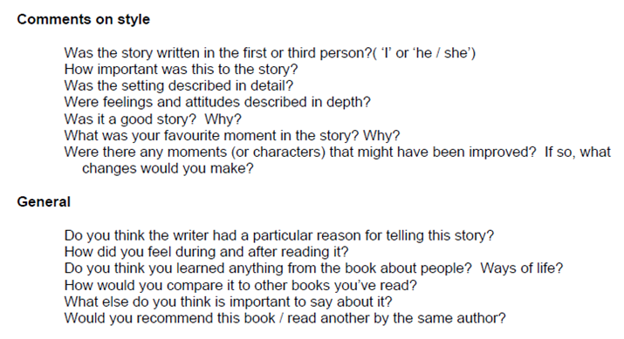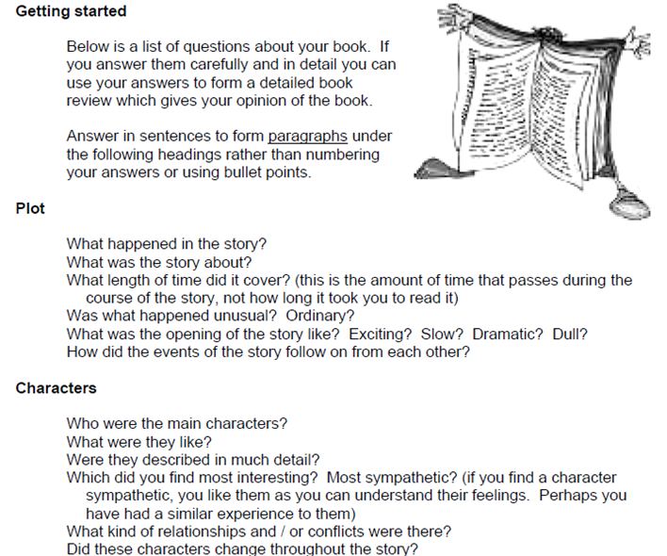**How to write a book review**