Hi everyone; I hope you are well and had a brilliant week last week – the snow on Monday was magical wasn’t it? Please try and do some English and Maths each day and then choose one of the other subjects to complete in an afternoon. I will give you some feedback when you send me your work, just like I do in class, so that you know what you have done well and how you might improve your work even further.

**Keep going Year 6 – You are amazing!**

|  |  |  |  |  |  |  |  |  |
| --- | --- | --- | --- | --- | --- | --- | --- | --- |
| **English** | Wonder by R.J. Palacio | Central Rappahannock Regional Library***Focus - Fiction - Wonder***  During lockdown, have you heard the saying:   |  | | --- | | ***‘In a world where you can be anything, be kind.’*** |   This week, I have chosen the book, **Wonder** by RJ Palacio which is the moving story of a little boy called August Pullman. Whether you have read the book before, seen the film, or it is all new to you, I hope you will enjoy the week of delving into the life of Auggie.  The whole book is available as a download on the link below – I am not asking you to read the whole book this week, but it would be great if you continued to read it over the next few weeks, a little bit each day, as it is a really powerful tale of triumph over adversity. I have read the beginning of the story to you, which is on our class Home Learning page so watch the video on Monday to get you started!  <https://www.readingsanctuary.com/wp-content/uploads/2018/10/Wonder.pdf> - this is the whole book which you can read on screen or print out (\*\*BEWARE – It is 220 pages long\*\*)  **Lesson 1** – Read and enjoy up to the chapter ‘*First Day Jitters.*’ (Page 35 if you have the book)   |  |  |  |  |  | | --- | --- | --- | --- | --- | | What are your first impressions of the following characters - August, Mom, Dad, Mr Tushman, Jack Will, Julian and Charlotte. **Jot down a few ideas for each character focusing only on what you have read**. (Not what you know if you have read/seen *Wonder* before!) You may have more than one impression of a character, in which case, write them all  **Lesson 2** – Imagine you were Auggie – how would you be feeling before your first day at school? **Write a short diary entry** for the night before you start school. Consider the following – your thoughts and feelings, your hopes for the day and your fears for the day. Now, watch the following clips from the film (Rated PG)  A) https://www.youtube.com/watch?v=Cp95gWHVejo  B) https://www.youtube.com/watch?v=zJMCctR8ivc  Then, read the chapter, *Choose Kind* up to the chapter, *September.* Consider how Auggie’s day actually went and think about his hopes and fears for the next day and his hopes and fears for friendships. Think through the events in chronological order – as they happened.  **Lesson 3** **and Lesson 4** – I am giving you 2 days to complete this task so that you have plenty time to research, make notes and put together your information page – this will preferably be hand written but you can do it on the computer if you prefer.  **Research the condition that affected Auggie - Treacher Collins Syndrome**. Use this website below:  https://www.health.com/condition/genetic-disorders/treacher-collins-syndrome  Have a look at this website below:  https://ccakids.org/  On the home page, scroll down to the section ‘Meet Our Kids.’ Take a look at a few real-life stories.  **\*\*Note: Parents – you may wish to watch these clips with your child to help with explanation and talk through any questions your child may have about this condition\*\***   |  | | --- | | **Produce an information page for a children’s magazine all about Treacher Collins Syndrome.**  Think about including the following:  - Facts about the syndrome and how it affects people.  - A phrase or hashtag about the importance of being kind  - Reference to the book  - Reference to stopping bullying  - Any useful websites  You can carry out your own research too to help you. Be as creative as you can and make your page visually appealing. ***Remember to think about the purpose and audience.*** The purpose is to provide information about Treacher Collins Syndrome. The audience is children, just like you!  **Lesson 5** Poetry – *Beautifully different, wonderfully the same!*  Read the following poem:<https://genius.com/Sugababes-ugly-lyrics> Look up the word ‘ugly’ in a dictionary/Word Hippo (online dictionary)  Now read this poem: <https://genius.com/Keala-settle-this-is-me-lyrics> (I bet you can’t read it without actually singing)  What does ‘unique’ mean? Look it up in a dictionary and write down the definition. Can you find some synonyms for the word unique? Note them down.  We are all unique! What makes you unique? Write down a list of things that make you unique. It could be something unique about  your appearance, about your family, about your hobbies/interests etc.  **Write your ‘Unique’ poem all about you.** Follow the format below. I have done one for you as a model (on the right) |      |  | | --- | | ***Reading***   * Daily reading is a must. At least 10 minutes is needed to maintain and continue the progress you have made.   **EXCITING NEWS!!! EXCITING NEWS!!! EXCITING NEWS!!!**   * The website below is a fantastic free resource bank, offering lots of quality texts online for children to read! The books are available simply by scanning a QR code and are arranged according to age. There is also a section on top reads for children (Wonder is one of these!), and a topic related page where you can find books related to many of our curriculum subjects.   <https://www.booksfortopics.com/storytime-online>  Find a book that you like the look of and enjoy!   * **EMC** –Complete another of the Reading Journal activity sheets (**Attachment 01**) Mix the activities up so that you are not always choosing the ‘drawing’ one * Have you already read some of these books? We read **The Boy at the Back of the Class** when you were in Year 4 – Try writing a book review (format at the end of the Home Learning Plan) encouraging (or discouraging) others to read the book. |  |  |  | | --- | --- | | |  | | --- | |  | | | |  | |
| **Maths** | ***Maths***  I am including video links to the White Rose Maths teaching videos. These should helpfully guide the children through the learning process for each unit covered. The corresponding worksheets are available on the school website on our Home Learning class page.  **This week we are continuing to cover Fractions as decimals and moving on to percentages**  [**https://whiterosemaths.com/homelearning/year-6/spring-week-2-number-decimals/**](https://whiterosemaths.com/homelearning/year-6/spring-week-2-number-decimals/)  **Monday – use the above link and scroll to Fractions as Decimals (1)**  [**https://whiterosemaths.com/homelearning/year-6/spring-week-3-number-percentages/**](https://whiterosemaths.com/homelearning/year-6/spring-week-3-number-percentages/)  **Tuesday – use the above link for Fractions as Decimals (2)**  **Wednesday – Understand percentages**  **Thursday – Fractions to percentages**  **Friday – FDP – Fractions – Decimals- Percentages**  \*\* **EMC** - If you wish to have a go at a SATs style paper with mixed Arithmetic questions, I have included this (with answers at the back for Parents) as **Attachment** **12**\*\*  **Additional Maths Activities**  TTRS - <https://play.ttrockstars.com/auth/school/pupils>  Arithmetic – **I have included some quick fire SATs style questions on percentages for you to try – leave this until the end of the week once you have done the Percentages lesson on Wednesday – Attachment 13**  \*\*See below for a few extra short Maths activities you can try (Ski Run and varied Arithmetic Questions)\*\*   * Ski – Run - <http://www.mathsbox.org.uk/re/sandc/srns/sr2%20(Web)/html5.html> |

|  |  |
| --- | --- |
| **RE** | **Jesus, Son of God**  This half term, we have been thinking about events in Jesus’ life that prove he is the Son of God with authority and power.  This week, we’re exploring people’s response to Jesus.  You can read an event here: <https://www.biblegateway.com/passage/?search=Luke+4%3A+31-37+&version=ICB> **Attachment 14**  Now read **Attachment 15** about Jesus healing people on a day called the Sabbath. Jesus is criticised for healing on the Sabbath? Why? Write down your response.  **Answer the following questions,** using **Attachment** **16** to help you. Research the questions and complete the table.  What is the Sabbath?  ShabbatWhen is the Sabbath?  Why is the Sabbath important?  Is the Sabbath remembered today?  Watch the clip ‘What is Shabbat?’ <https://www.youtube.com/watch?v=JpFw7DqRMEc> Write down notes in bullet form about what you learn.  \*\***EMC** - Write an email or a text message (on paper) that you would send to your friends telling them about an event where you met Jesus. Use informal language as you are communicating with friends and imagine their response!\*\* |
| **Science** | **Our unit is Earth and Space**  Start by watching Tim Peake returning to Earth – you may want to skip through some of this video  <https://www.youtube.com/watch?v=srUu8batsmc>  C:\Users\boltonr\AppData\Local\Microsoft\Windows\INetCache\Content.MSO\1F4D89A3.tmp  This week we are getting practical by **designing a parachute** to make sure the astronauts land safely!  You will investigate different materials, shapes and sizes  You will test your parachute and record the results accurately  You will analyse your parachute and evaluate the effectiveness  Experiment with different materials, shapes, layers etc. Maybe, build your parachute from paper, kitchen roll, fabric, tissue, felt – try to attach a weight such as a ball of blue tack, screwed up foil, a small toy, using string or wool.  <https://www.youtube.com/watch?app=desktop&v=STDJ0l0cvFo> may give you some ideas when making your parachute  Look at how surface area affects the parachute The greater the surface area the slower the fall- why?  Think about how air resistance (air pushing back up) slows down the fall.  **Write a paragraph of work** explaining how you made your parachute, how well it performed and an explanation as to why it succeeded or failed. How would you improve your design?  **Science Sparks - Millgate House Education**  \*\* **EMC** – Use the Science Sparks Space Activity booklet which has oodles of different Space investigations in it that you can do at home.\*\* **Attachment 17**    You might make a squeezy bottle rocket or a model of The Soyuz.  Please send me any photographs of you doing any of these experiments – I would love to see them!   |  | | --- | |  | |
| **Art** | Cubism was the first abstract art style. Cubist painting abandoned the tradition of perspective drawing and displayed many views of a subject at one time.  Cubism was a truly revolutionary style of modern art developed by Pablo Picasso and Georges Braques. They wanted to change the conventional way art was created and viewed.  This week continues with abstract portraits however, there’s a twist!  You are going to **create a piece inspired by Pablo Picasso** using a ‘Roll and Draw’ game. **Attachment 18**  You will roll a die in order to pick which face shape, eyes, mouth, nose etc your face will consist of. After you have drawn your face add lots of bright colours. Remember Picasso didn’t draw faces in the traditional style, the eyes, nose, mouth etc didn’t always sit where they would on your face, or in the same shape or size you would expect. Take a look at the example for ideas.  If you do not own a die/dice don’t panic you can ask a family member to choose a number between 1-6.  **\*\*EMC** – Can you give your picture a title or name?\*\*  Miss Watson has set your Art for this week.  She would really like to see what you achieve so please send any photographs of your artwork to:  [**b.watson@leacofe.lancs.sch.uk**](mailto:b.watson@leacofe.lancs.sch.uk) |

|  |  |
| --- | --- |
| **Geography -**  **Extreme Weather** | This week, we are looking at FLOODING.  China floods: Over 140 dead as Yangtze River bursts banks | News | DW |  13.07.2020What is flooding? Research the types of flooding that can occur (river flood, urban flood, flash flood, coastal flood, etc).  What might be different about each one?  How might different floods affect people depending on where they live?  Compare flooding in Britain to flooding in Bangladesh – this short video looks at flooding in Bangladesh… <https://www.bbc.co.uk/programmes/p01150zl>  …and this one looks at flooding in different parts of the UK <https://www.bbc.co.uk/news/uk-19693499>  What are the similarities and differences?  **Create a wordsearch** using key flood vocabulary: **flood, water, rain, extreme, prolonged, flash, levee, overflow, headwater, storm.** Use **Attachment 19** to hide your words.  Write a list of the 3 things you would want to take from your home in the event of a flood. Explain why you have chosen these items? Are they for practical reasons or are they sentimental?  \*\***EMC** – Are there any benefits to flooding? Explain your answer\*\* |
| **PE** | Noughts And Crosses Game On Outdoor Children Playground. Stock Photo -  Image of children, develop: 176147462  **Coordination, Balance and Decision Making**  **Task 1** – **You will need a balloon** - Using a balloon, your task is to **keep the balloon off the floor!** Simple as that, however…..  You cannot use the same body part more than twice in a row. Challenge yourself, make a score and then try and beat it by another 10 seconds and so on.  **Task 2 – You will need imagination to mark out a grid or use chalk to draw a grid outside if it is a dry day! You will also need two lots of 3 similar colour objects eg 3 oranges or 3 white socks etc**  This activity requires another person to participate with you so rope in mum, dad or a brother or sister! Even a very intelligent pet could help….!  The aim is to **play noughts and crosses** but a slightly bigger and more active way of doing it. Using any equipment you may have, each person has 3 markers of the same colour or object, you sprint out putting one of your objects into an empty spot, at the same time your opponent will be doing the same with theirs.  The first person to get the three objects in a row will win. If nobody has created a line, you may then go and move one of the already placed objects into a new empty one. Tune into the video link below for a full demonstration  <https://youtu.be/8LkCCvjuF7w> |
| **PHSE** | Winding Road Into Distance HD Stock Images | Shutterstock**Decisions and Resolutions**  Draw a line or shape (or use this picture as a guide) to represent a path for a life as you prepare for the change of leaving primary school and starting secondary school. Your path can extend even further if you would like it to.  **Write down the challenges you might face in one colour pen on one side of your path and how you would overcome each challenge in a different colour on the other side of your path.**  Supporting Fast-Moving Business Requirements Using Approval Branching -  Shine Solutions Group  **EMC**: Think about the decisions we need to make in life to choose the ‘right path’. There is a picture here of a path branching into two. What temptations will there be to follow the ‘wrong path’? What happens if we make mistakes and end up on the wrong path How can we find our way back?  Don’t forget – February 3rd is **Inside Out Day** which ties in with Mental Health Week. Wear an item of clothing inside out, take a photograph and send it to me! |
| **Computing** | This half term, we would be looking at Spreadsheets in Computing  During this lesson you will be taught that objects can be described using data. **You will build a data set** (a collection of related data that can be manipulated using a computer) **within a spreadsheet application and apply appropriate number formats to cells**.  Watch the **Oak National Academy** lesson 2 – Modifying Spreadsheets - follow the video<https://classroom.thenational.academy/lessons/what-is-a-spreadsheet-c9h3jc?activity=video&step=1> |
| **Picture News** | C:\Users\boltonr\AppData\Local\Temp\Temp1_Primary Picture News Resource England - 1st February - Mountains.zip\Picture News Poster - 1st February.jpg  **Who has climbed the world’s highest mountain?**  Joe Simpson said ‘If you succeed with one dream, it’s not long before you’re conjuring up another, slightly harder, a bit more ambitious, a bit more dangerous.’ Do you think everyone feels this way? Do you have dreams and ambitions? Would you describe them as dangerous?  Option 1: Read and research a mountain of your choice from anywhere in the world! You could include:   * Its name. * Where it is located. * Its height. * Its average temperature. * What its climate is like. * Information about any plants and animals that live there.   You could organise the information in a fact file, a poster or a leaflet. If you really want a challenge, create a non-chronological report about your mountain! |

**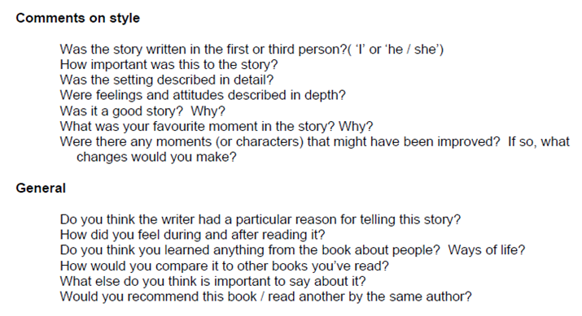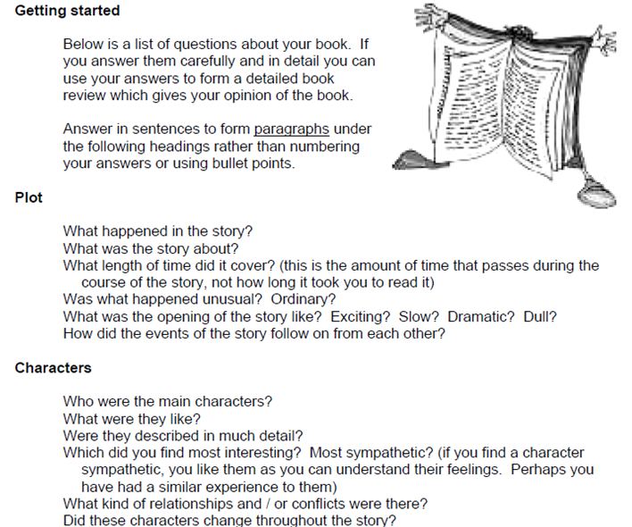How to write a book review**