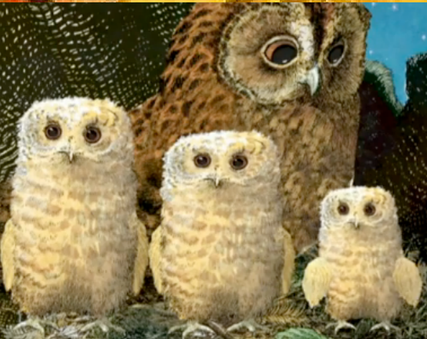
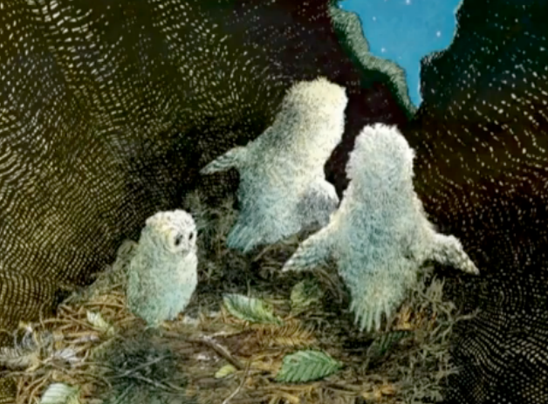
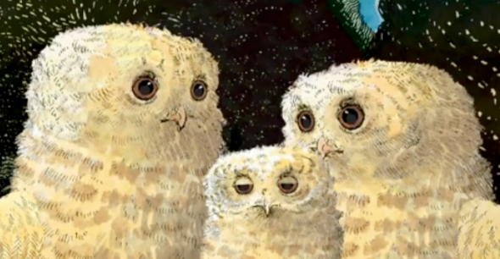
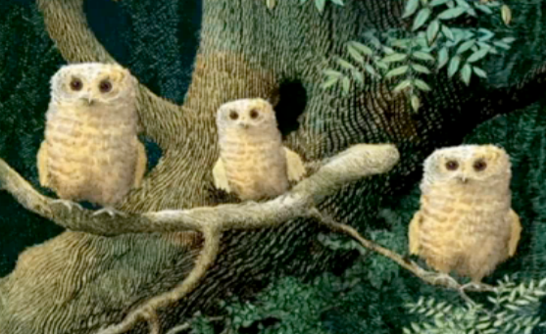
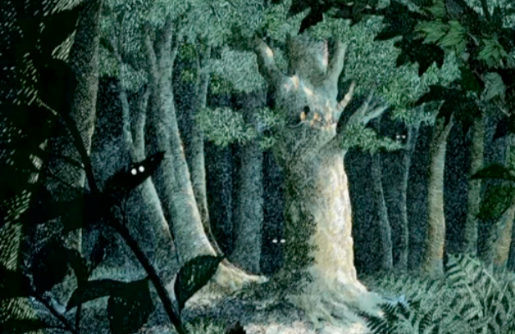
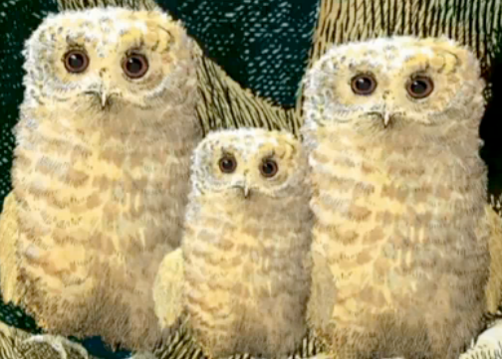
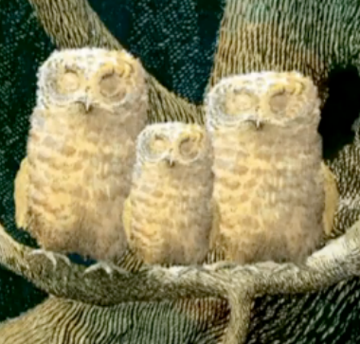
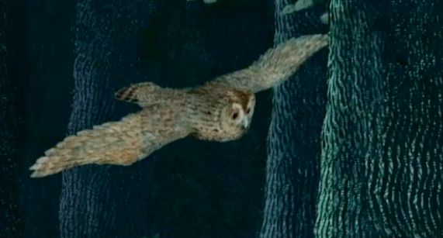
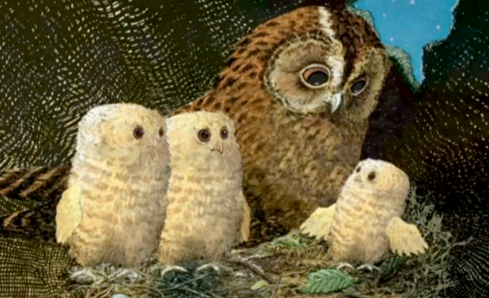
Once there were 3 baby owls, they loved in a hole with their mum.
One night they woke up and their mum was gone.
I think she has one hunting to get us food. I want my mummy.
They came out of their hole and sat on the branches.
It was dark in the woods.
I think we should all sit on one branch.
They closed their eyes and wished their mummy would come home.
Mummy owl came back.
I love my mummy.

