Maths Building 9 & 10 - Week 1 | White Rose Maths  This week we are exploring numbers 9 and 10. You will explore the different ways the numbers can be made (composition)  Explore how many different ways you can make 9. Then see how many different ways you can make 10. What do you notice? Can you spot numerals 9 and 10 in the environment?  Have a look at each card on the screen. Does it represent 9 or 10? Sort the cards into two groups. Now make your own cards to represent 9 and 10. Have a go at sorting these cards too.  Order numerals 1-10 Ask a helper to change something on your number line. Can you spot the mistake and correct it?  Look at Teddy's number 9 picture. Draw your own number 10 picture using 10 black dots. Then have a go at drawing another picture, exploring the different ways you can show 10.  Play your own game of bingo. You could use one of the bingo cards on the white rose page or you could make your own.  Extra challenges  ∙Look at the two challenge cards on the home learning page of the school website. Maybe you could choose two challenges off the number 9 card and two challenges off the number 10 one.  ∙Fill in the missing numbers on the worksheet. Can you work out which are missing? Explain how you worked it out using mathematical language, eg one more, one less, between.  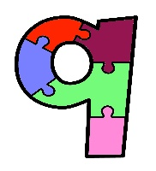  This Photo by Unknown Author is licensed under CC BY-SA-NC | English  Read our online, interactive Owl Babies storybook | BookTrust  This week we are looking at one of our favourite stories – Owl Babies by Martin Waddell.  ∙Write a letter to the owl babies suggesting what they could do if they start to feel scared or worried in future.  ∙Research owls using the Internet or some simple non-fiction texts. You could write some simple fact cards using the information you have learnt.  ∙Look through your books and pull out the ones that have a woodland setting. Are there any similarities? Draw and name some of the characters that crop up in a few of the books, eg owl, fox, mouse.  ∙Write a new story that tells of the mother owl’s adventures whilst she was away. Maybe you could make a zig zag book of your new story.  Extra challenge  Make up your own character for a story with a woodland setting. Draw your new character and write a list describing them, eg Freddy Fox – clever, hungry, adventurous.  Reading  Read daily using the Oxford Owl website using our class login.  https://www.oxfordowl.co.uk/  Username: recep19 Password: bamber  Phonics  Watch Mrs Moores’s video to hear about oo, ar, or. Watch the short oo, ar, or videos on Phase 3 phonics - KS1 English - BBC Bitesize  Picnic on Pluto (phonicsplay.co.uk) Play the game by reading the oo, ar, or words, and deciding if they are real or imaginary words.  Practise writing the letters using your best handwriting. Maybe you could write some words with each phoneme, eg spoon, book, card, fort.
RE http://www.creativefaithforkids.com/2017/03/how-to-make-prayer-tree-for-lent.html

Last week we thought about who we love and who loves us. This week you could create a prayer tree. You might have a small display tree already, but if not you could make your own. Collect some twigs from outside and put them into a vase or pot. You could find a ribbon to decorate it. Cut out some heart shapes to use for leaves, then draw or write prayers on the hearts thanking God for the people who love you and for his love for us.
Extra Challenge
Carry out a project of love, for example make cards or gifts to send to a family member you miss, or do some fund raising for charity.
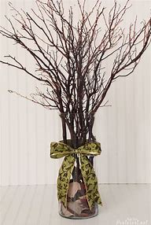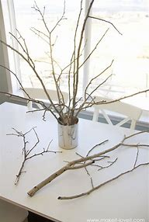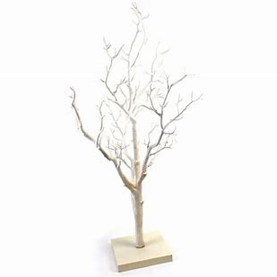
Science What is a woodland habitat? - BBC Bitesize
Find out which animals make their homes in woodland. Think about why the woods are the best place for them to live, eg tall trees, earth to dig tunnels in, undergrowth to hide in. Watch the video and then click and drag the correct animals that live in the woods. Try and answer the quiz questions - you might need a grown up to help you read the animal names. Learn the new word – habitat.
Extra Challenge
Create a collage of a woodland scene. You could use the sheets on the home learning page or draw your own. Find a photograph of a woodland scene and draw it. Next draw some animals on paper, cut them out and stick them in the correct habitat on your woodland scene.
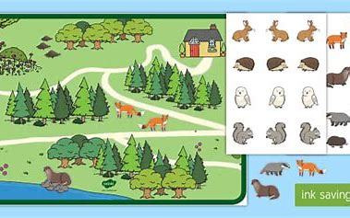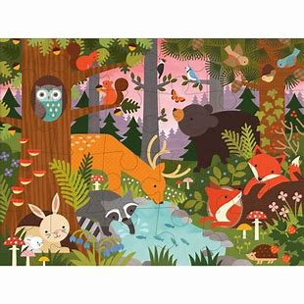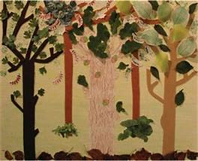
Art https://www.wassilykandinsky.net/work-370.php

Last week we found out about the artist Kandinsky. Look at the picture of the circles. It is an abstract painting – can you remember what this means? What do you see when you look at this painting? What kind of colours does Kandinsky use? What shapes can you see? Do you like it? Why? Make your own version of the picture using any pens, pencils, felt tips or paint you have at home.
Extra Challenge
Make a Kandinsky circle with plasticine or playdough. Make three balls of different colours and sizes. Place them on top of each other, biggest at the bottom. Now squash!
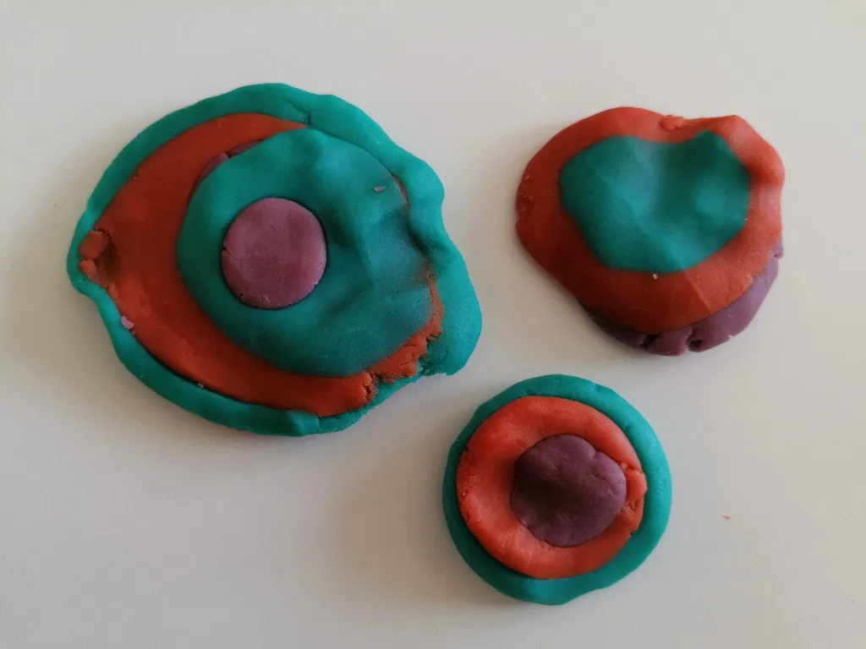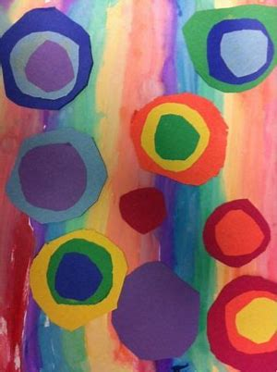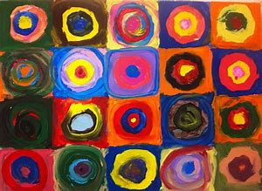

Music Free Songs & Resources | Out of the Ark Music @Home | Out of the Ark Music

Listen to ‘I heard a blackbird singing’ on Week 7. Try and join in and learn the lyrics and the melody. The song talks about four different birds. Go to the RSPB website to find out more about each one and to hear their unique songs. Simply put ‘RSPBblackbird’ or ‘RSPBhousesparrow’ etc. into your search engine. When you next get out in the garden or go out for a walk, stand really quietly and listen really carefully. Make a list of all the different sounds you can hear in one minute. Can you hear any birdsong? Do you recognize it? Can you record the sounds on a phone or tablet? Why do you think birds sing?
Extra Challenge
Make a ‘dawn chorus playlist’ of some of your favourite family songs to wake up to tomorrow!
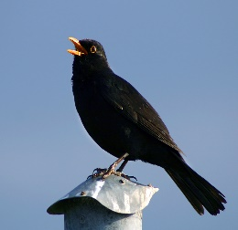
This Photo by Unknown Author is licensed under CC BY-SA
This Photo by Unknown Author is licensed under CC BY-NC-ND
Dance https://www.bbc.co.uk/teach/school-radio/ks1-dance-lets-move-greedy-zebra-news-travels-fast/zbvsnrd (free resource but registration is required)

Listen to the next part of the story of 'Greedy Zebra' by Mwenye Hadithi. In the story the news travels about the wonderful cave and all the animals rush to look - except one. See if you can join in with the story. The session focuses on contrasting movement; travelling; reaching and stretching; body shape.

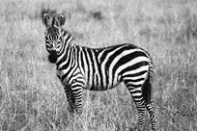
Outdoor Learning Nature Art - Bark Rubbings - YouTube

Go for a walk in a wood or a park with trees. Try and spot some trees that might have holes in them for owl babies to live in. Maybe you could explore the textures of the tree by making a bark rubbing. Look at the bark and talk about how it feels, using new words to develop your vocabulary. Hold the paper onto the tree trunk and gently rub the crayon over the picture to reveal the pattern of the bark. Try and use different colours to make it as bright as a Kandinsky painting.

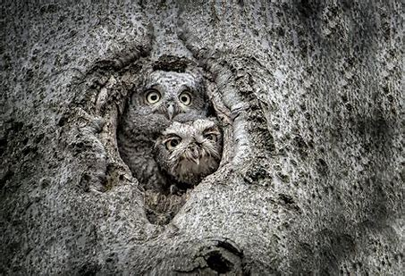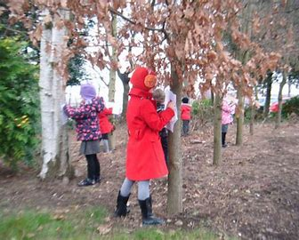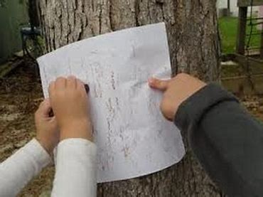
How to jump
- Keep ankles, knees and hips bent.
- Look towards where you are jumping.
- Swing arms back, ready to jump.
- Both feet leave the ground at the same time.
- Swing arms forwards as you jump and land.
- Land as quietly as you can on both feet at the same time, keeping ankles, knees and hips bent.

PE JUMPING CHALLENGE
Try and do a different jump each day!

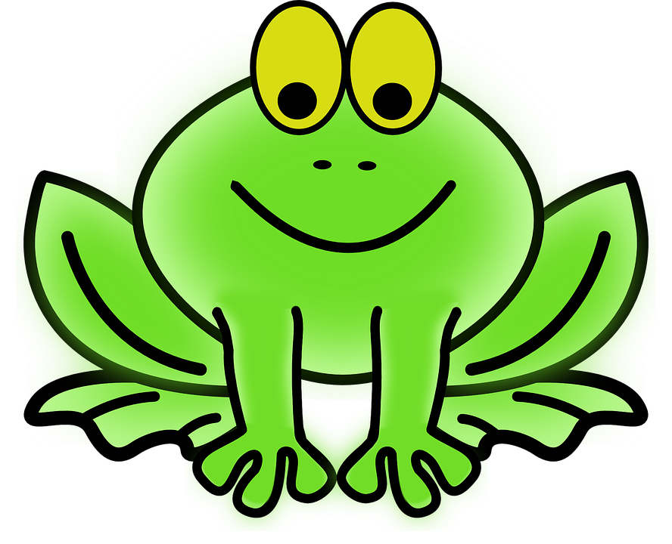

Frogs or Rabbits
Play with a grown up. When the grown-up shouts out ‘frogs’ try to jump as far as you can. When the grown-up shouts out ‘rabbits’ try to jump as high as you can.

Can you reach it?
A grown-up will hold something above your head, eg a teddy. Jump as high as you can to reach it. How high can you jump?
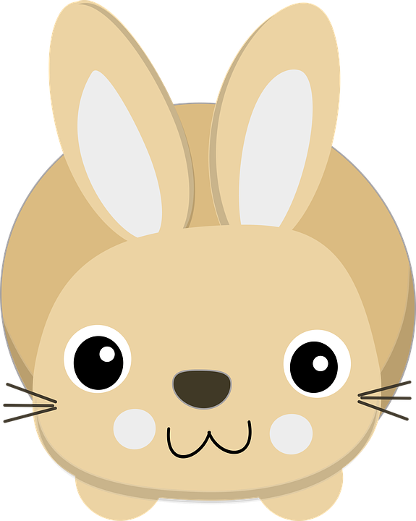

Don’t go down the hole!
In a safe space lay out some old boxes, eg cereal box, shoe box. These will be the holes that you
must jump over! See how many holes you can avoid.

Number Jump
Using chalk on the floor or an old sheet, write a range of numbers in a random order. When your partner shouts out a number or rolls a dice, try to jump to the correct number.

