Hi everyone; can you believe that we are in Lockdown – week 4? Here is your learning for this week. Please remember what I said last week on Zoom. I need to see some of your work so that I know we are all keeping to a routine and preventing our brains getting rusty. Please try and do some English and Maths each day and then choose one of the other subjects to complete in an afternoon. I will give you some feedback when you send me your work, just like I do in class, so that you know what you have done well and how you might improve your work even further.

Keep shining Year 6 – I know you can do it!

|  |  |  |
| --- | --- | --- |
| **English** | ***Focus - Non-Fiction – Balanced Argument***  C:\Users\boltonr\AppData\Local\Microsoft\Windows\INetCache\Content.MSO\4D4CDC62.tmpContinuing our theme on Earth and Space, you are going to consider the opportunity for people to make a one way trip to Mars. Last week, you were asked to watch the video below and write down a list of pros and cons to taking this journey.  **Task 1 –Watch the Mars One video a second time to refresh your memory** [**https://www.youtube.com/watch?v=n4tgkyUBkbY**](https://www.youtube.com/watch?v=n4tgkyUBkbY)   * **Lesson 1** – Attachment 1 read attachment 1 and compare to your list of pros and cons – did you get the same or did you think of some of your own not mentioned here? Use the planning template Attachment 2 to begin work on your discussion text - **Is living on Mars a good idea?** Think about what you would like to write about and words/phrases you are going to use. **Make notes today** * **Lesson 2** – Write your **introductory paragraph.** This paragraph needs to introduce the theme and give a brief explanation about the voyage – what it entails. Remember that you cannot take sides so do not use emotive language to sway your reader for or against! You do not use ‘I’ in this text but use the third person instead – **People may….., One might consider….., Scientists think….. etc** * **Lesson 3** – **Write your second paragraph** – arguments **for** the project. Use the useful sentence starter sheet Attachment 3. You must make each point for the project and elaborate on it, giving evidence to support each point. You may wish to watch the clip again and use Attachment 1 to help. Your argument should be written using formal language and try and include some technical science vocabulary to make it sound professional! * **Lesson 4** – **Write your third paragraph** – arguments **against** the project. Like yesterday, make each point and then support with key evidence. Use logical conjunctions such as **furthermore, besides, likewise, as well as , in the same way, in addition to etc** * **Lesson 5** **- Write your summary paragraph –** This may start**, In conclusion……..** and lead the reader to make up their own minds as to whether they are for or against the project. You may end with a question which would promote further discussion amongst your readers!   **\*\*EMC:** Write a separate paragraph telling me about your opinion to the Mars One project. This time use the first person, ‘I’ and this time, you are allowed to use emotive language to convince me you are right! \*\* | |
| ***Reading***   * Daily reading is a must. At least 10 minutes is needed to maintain and continue the progress you have made. * **Oak National Academy now have a virtual library facility where children can access books online for free**.   **Every week a popular children's author or illustrator will provide you with free books, exclusive videos and their top three recommended reads. Check it out following the link:**  <https://library.thenational.academy/>  I have created an account on [www.oxfordowl.co.uk](http://www.oxfordowl.co.uk). It is a free resource that gives a range of reading books that follow the school reading bands.  **Username: class5lea**  **Password: shine**   * When you have finished a book, complete a book review. I have included an example of how you might do this at the end of your home learning. * You may also complete some of the activity pages in your Home Reading Diary * **EMC** –Complete another of the Reading Journal activity sheets (**Attachment 04**) Mix the activities up so that you are not always choosing the ‘drawing’ one | ***Writing***  **Complete the new SPAG questions** I am sending home. Attachment 5  Perhaps try and do a couple of pages each day as a warm up.  There may be some work on here which we have not yet covered – see if you can find out definitions for unfamiliar words eg **determiners,** to help you complete the questions  **\*\*Parents – the answers are at the end of this paper for you, so please only print out the questions for the children!! \*\***  **EMC** – I wrote you all a letter last week (available in our class section of the website). Please write me a letter back, telling me everything you have been up to. You could e-mail it to me or even post it which would be a real treat!  **Mrs R. Bolton,**  **Lea Endowed C of E School,**  **Lea Road,**  **Preston.**  **PR4 0RA** |
| **Maths** | ***Maths***  I am including video links to the White Rose Maths teaching videos. These should helpfully guide the children through the learning process for each unit covered. The corresponding worksheets are available on the school website on our Home Learning class page.  **This week we are continuing to cover Numbers – Decimals**  <https://whiterosemaths.com/homelearning/year-6/week-1-number-decimals/>  **Monday - Lesson 5 – Divide by 10, 100 and 1000**  [**https://whiterosemaths.com/homelearning/year-6/spring-week-2-number-decimals/**](https://whiterosemaths.com/homelearning/year-6/spring-week-2-number-decimals/)  **Tuesday - Lesson 1 – Multiply decimals by integers**  **Wednesday – Lesson 2 – Divide decimals by integers**  **Thursday – Lesson 3 - Division to solve problems**  **Friday – Lesson 4 – Decimals as fractions**  \*\* **EMC** - If you wish to extend your learning further in this area of Maths, **Attachment 16**, has some additional SATs style questions for you \*\*  **Additional Maths Activities**  TTRS - <https://play.ttrockstars.com/auth/school/pupils>  Arithmetic - <https://myminimaths.co.uk/year-6-arithmetic-practice-papers/> - scroll down and click on **WEEK 5** practice paper – have a go at the questions and then check them in the answer section.  \*\*See below for a few extra short Maths activities you can try (Ski Run and varied Arithmetic Questions)\*\*   * Ski – Run - <http://www.mathsbox.org.uk/re/sandc/srns/sr2%20(Web)/html5.html> | |

|  |  |
| --- | --- |
| **RE** | Hannah Dunnett Trust in God A3 Poster **Jesus, Son of God**  This week, the event is known in the Bible as ‘Jesus Calming the Storm’.  You can read the story online here: <https://www.biblegateway.com/passage/?search=Matthew+8%3A23-27&version=ICB> **Resource 17**  ***Complete at least two of the following tasks.***  1) Create an emotion graph for this event from the perspective of the disciples. Use **Resource 18** as an example.  2) Rewrite the story using more adventurous vocabulary. Watch <https://www.youtube.com/watch?v=tHAVs1GEUzc&ab_channel=SharefaithKids> for an example that using vocabulary that mirrors the event itself.  3) Draw a picture retelling this event.  4) Create a piece of artwork in the style of Hannah Dunnett retelling this event.  5) Look at the words ‘Praise You in the Storm’ by Casting Crowns <https://www.youtube.com/watch?v=MgpaULjZOl8&ab_channel=CastingCrowns> (Lyrics: <https://castingcrowns.com/music/praise-you-in-this-storm/>). Write down what this song tells us about life as a Christian. |
| **Science** | Why does the Moon have phases? - skyatnightmagazine**Our unit is Earth and Space**  This week, we are thinking about the Moon  What shape is the Moon? Does it always appear as a circle in the sky? Does the Moon actually change shape or appear to change shape?  Before you do any research, think about these questions and either write down your thoughts or discuss them with a family member.  Now, watch the Powerpoint which explains the movement of the moon in relation to the Earth.  This is **Attachment 19.**  Your task is to **draw a diagram or use a model to describe the Moons orbit around the Earth**  **Science Sparks - Millgate House Education**  \*\* **EMC** - For those of you who love Science or enjoy learning in a really practical way, I have attached a Science Sparks Space Activity booklet which has oodles of different Space investigations in it that you can do at home.\*\* **Attachment 20**    You might make a squeezy bottle rocket or a model of The Soyuz.  Please send me any photographs of you doing any of these experiments – I would love to see them!   |  | | --- | |  | |

|  |  |
| --- | --- |
| **Art** | Miss Watson has set your Art for this week.  She would really like to see what you achieve so please send any photographs of your artwork to:  [**b.watson@leacofe.lancs.sch.uk**](mailto:b.watson@leacofe.lancs.sch.uk)  **Create an Abstract face** – use Google to help inspire you.  Remember Abstract Art is non-traditional and is very quirky, so faces will not look like a picture you have taken, it will include shapes and colours that you wouldn’t find on a true likeness picture.  Don’t be afraid to experiment with your colours, the bolder the better |
| **Geography -**  **Extreme Weather** | Last week, you should have researched a significant earthquake and created a poster, telling me all about it.  One of the effects of Earthquakes can be tsunamis. Read some facts about tsunamis by following this link:  <https://www.ducksters.com/science/earth_science/tsunamis.php>  Art Lesson Plan - The Great Wave - Hokusai - KS2 | Teaching ResourcesFor your work this week, see if you can **answer the 10 quiz questions** at the end of the information. You do not need to write anything down.  \*\*EMC – This is a painting called **The Great Wave** by Hokusai, a Japanese artist. You could create a similar piece of Art,  depicting a tsunami \*\* |

|  |  |
| --- | --- |
| **PE** | **Colour Combination**  • Lay out several different coloured objects on the floor.  • Partner one chooses three different coloured objects for partner two to run out and touch.  • When partner one says go, how quickly can partner two touch the coloured objects in the correct order?  • To make the game harder increase the number of colour objects that are called out or put the objects in different rooms. |
| **PHSE** | **Advertising friendships!**  Snapchat features 'real friends' in debut global ad campaign150 is called Dunbar’s Number. A man called Robin Dunbar has suggested that 150 is the maximum number of people that a person can manage to have a stable social relationship with. That is, a person can really only know and understand how 150 people relate to one another.  In our lives we have many types of relationships. Perhaps one of the most important is a friendship. Have a think about these questions   * Why do you consider friends important? * What’s the difference between a friend and acquaintance? * When/how does an acquaintance become a friend? * Why would a friend become an acquaintance?   You are going to **put together a short advertisement** for a friend in which the qualities you feel are really important are clearly communicated. The advert should be one for TV. It can include speech, song, poetry, dance  You can write this out, use notes or even record this as though you were a TV Presenter!  There is a time limit of **1 minute** for the finished product.  \*\***EMC** - Explain that other relationships are important in our lives too.  Can you finish the following sentences? \*\*   1. It’s helpful having an aunt or uncle because… 2. It can be useful being an older sister/brother because… 3. It can be helpful having friendly neighbours because… 4. A carer or guardian is really important to me because… |
| **Computing** | This half term, we would be looking at Spreadsheets in Computing  Watch the **Oak National Academy** lesson 1 – What is a spreadsheet? and answer the questions within the video  <https://classroom.thenational.academy/lessons/what-is-a-spreadsheet-c9h3jc?activity=video&step=1> |
| **Picture News** | **C:\Users\boltonr\AppData\Local\Temp\Temp1_Primary Picture News Resource England - 25th January - Leaders.zip\Picture News Poster - 25th January.jpgDo you think anyone can be a leader?**  **Can you think of a time when someone has had to lead that didn’t want to?**   * Create a list of some of the leaders you know e.g. your teacher, someone who runs a club you attend, school council members, your local MP, the captain of a sports team. * What makes them good leaders? Can you record a list of qualities that you think a leader should have e.g. positivity, resilience, good communication skills. Do you think your list of qualities will be the same as someone else’s? Can you compare it to someone else’s in your class or at home? * Have you ever led anything e.g. part of a PE lesson, been a school council member, playground leader or sports leader, been in charge of younger children in school? What was it like? Did you enjoy being a leader? |

**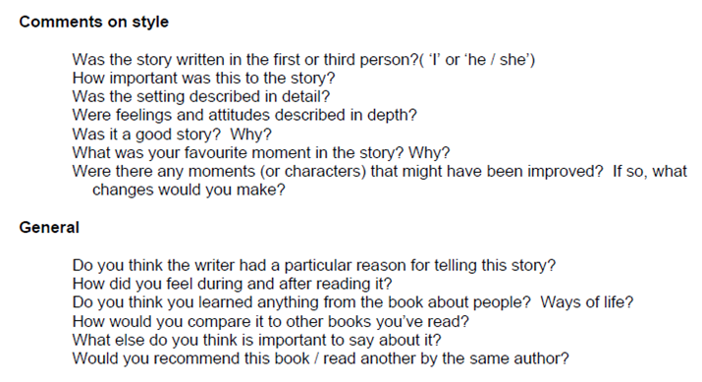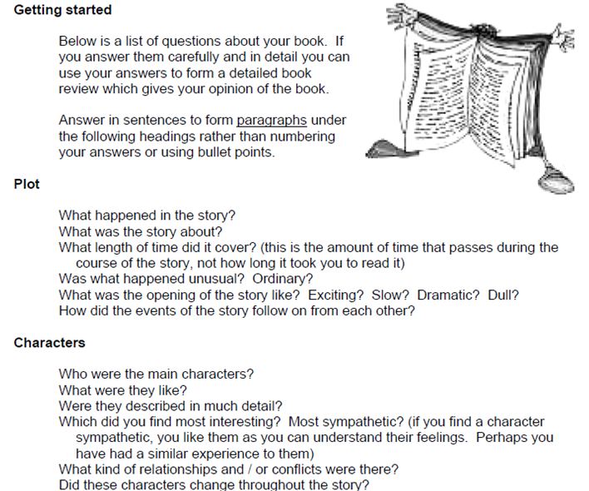How to write a book review**