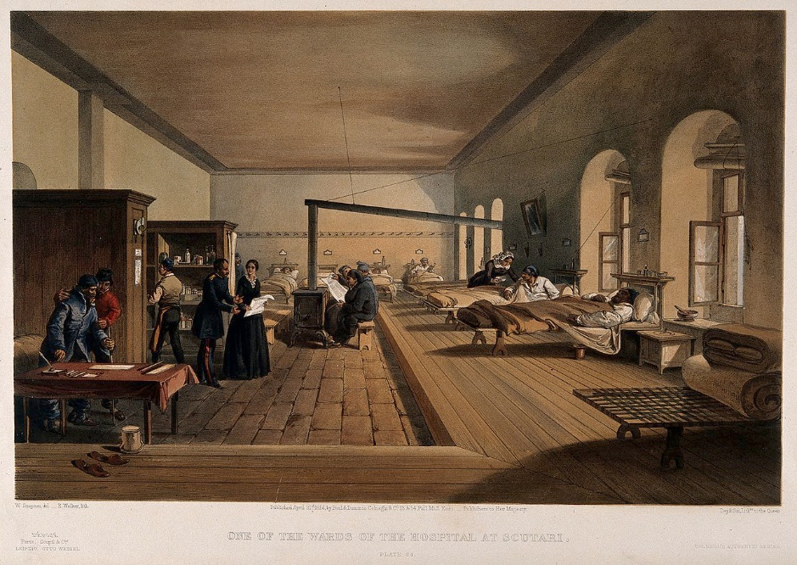
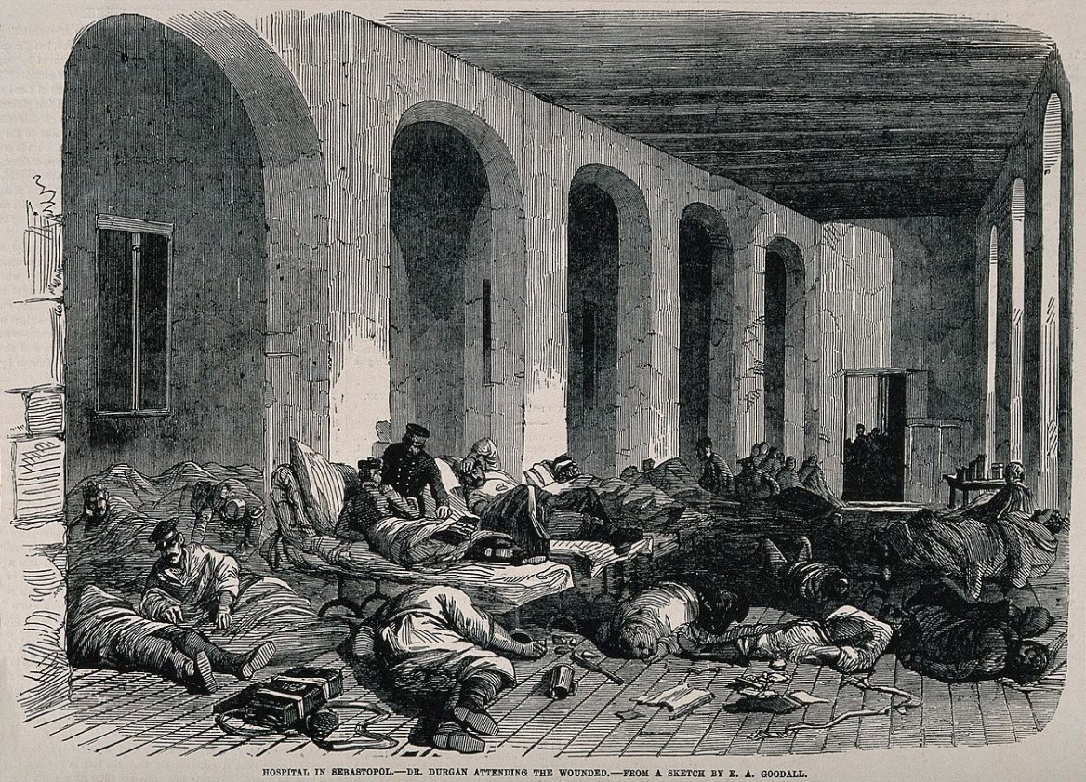

Scutari Hospital Before and After Florence Nightingale
Look at the two pictures. How has Florence improved the hospital for the soldiers so they can recover and get well again? List 3 improvements she has made.

