Maths  This week the focus for our maths learning is Time.  Please access learning via the link below and select the Year 2 Summer Week 12.  https://whiterosemaths.com/homelearning/summer-archive/year-2/  The related worksheets and answers for this week can be found on our home learning page. Complete one video and/or the related worksheet activity each day.  Monday – Make a clock practical activity & reading times  Tuesday – Telling the time to 5 minutes video & worksheet  Wednesday – Hours and Days video & worksheet  Thursday – Durations of Time video & worksheet  Friday – Compare durations of Time video & worksheet  Extra Miler Activities for our Year 2 “Math Professors”  Join the Cheerleader this week to get moving and learning about time.  https://www.bbc.co.uk/teach/supermovers/ks1-maths-telling-the-time/zk4t8xs  Or you could try these time games and activities.  https://mathsframe.co.uk/en/resources/resource/116/telling-the-time  https://mathsframe.co.uk/en/resources/resource/117/telling_the_time_in_words#  https://www.topmarks.co.uk/time/teaching-clock  Times Tables  https://www.ictgames.com/tablesTennis/mobile/index.html  This week have a go at this times table game. Choose x10 tables and practise your memory skills. You can play alone or with a family member. |  | 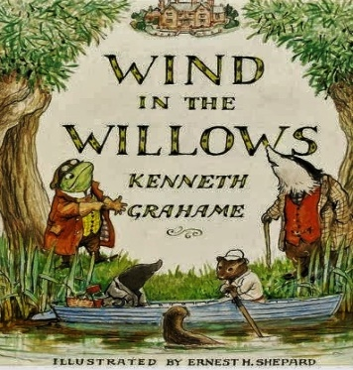  English – Wind in the Willows  Our class text for the rest of this half term is the classic story Wind in the Willows.  You can view and enjoy the story via this link below. https://www.youtube.com/watch?v=gtX9ycjUIoE  Monday – Watch the first seven minutes of the film. Which animal character do we meet first? Where does he live? Research this animal and create a fact file. Include 3 amazing facts.  Tuesday – Mole visited Ratty when he got fed up of spring cleaning. Ratty lives on the river bank. Can you research another animal that lives in or by riverbanks?  Wednesday – Continue watching the film for the next five minutes until 12 minutes. Make a list of all the different animals he meets or learns about. Which animal would you like to know more about? Use the questions words ‘WHO, WHAT, WHERE, WHY, WHEN & HOW’ to write your questions. Remember your question marks.  Thursday – Watch the next five minutes of the film up to 17 minutes. Draw a picture of Mr. Toad. What words are used to describe him? Collect and add the words around your picture. Write five sentences about Toad using the words you have collected.  Friday – Watch the next 1½ minutes of the film. (up to 18m 30secs) What is Toad’s new discovery? What does he want to buy now? Poop, poop!  Draw a picture of the vehicle. What do you think will happen next in the story? Write your prediction underneath your picture.  Remember to use your capital letters, full stops, finger spaces between words and your best handwriting.  Reading – Read daily via the Oxford Owls website using our class login.  https://www.oxfordowl.co.uk/  Username: leaclass2 Password: dragon  You can also access some wonderful stories to share with your child via the following link.  https://www.booksfortopics.com/storytime-online  Spelling, Punctuation and Grammar (SPAG)  Please see the spelling overview on the home learning tab for the spellings for Week 2 - /ee/ spelt with ‘_ey’.
Geography & Science – Animals and their Habitats  View the links below. You will find a video and activities about rivers.  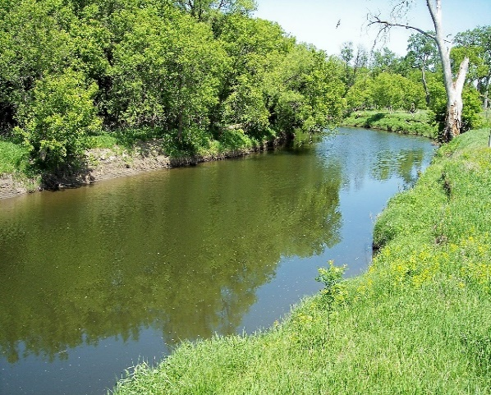  https://www.bbc.co.uk/teach/class-clips-video/geography-ks1--ks2-rivers/z6qsf4j  Look at this photograph of a river.  Do you have a river near where you live?  What is it called?  Think of 3 words to describe a river habitat.  Watch the PowerPoint presentation about Animal habitats. You will find this in the worksheet section.  Rivers are home to many animals including fish and birds.  Why not try some of the duck craft ideas pictured below?  Have fun! Quack, quack!  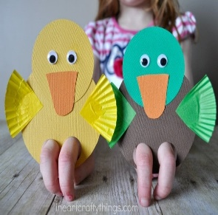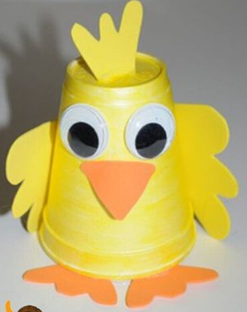  Challenge:  Continue using your scientific and geographical knowledge to help the Pirate Bunnies on their World Adventure.  https://www.bbc.co.uk/bitesize/topics/zvsd8xs/articles/z6vyf4j |  |  | R.E - Easter  This half term we will be learning about Easter and asking the following questions.  What is love?  Where is love?  Who do you love?  Who loves you?  How do you/they show that love?  How did Jesus show that he loved us?  The story of Easter is filled with many different emotions, but through it is the story of God’s love for us all.  https://www.youtube.com/watch?v=LPLwMxogYDU  Read ‘Guess how much I love you’ or share the video above. Show your family how much you love them by doing special things for them.  Eg. Paint a picture for someone, help them with some jobs, read to your grown up a favourite story or send a card to someone in your family you’re missing at the moment.  Challenge  Make up your own version of the book ‘Guess How Much I Love You’, suggesting your own measurements of love. Draw a picture showing how much love you have or make a card for someone you love.  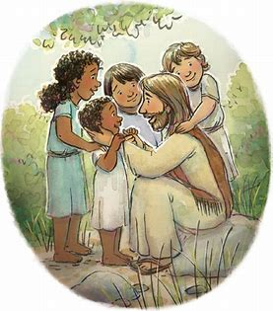
Computing – Graphics and Text  If you have access to the Busythings website at home you can select the Paint and Publishing tool in the Art section to create your own abstract river picture like the one above. Or use any paint app that you have access to.  Create a ‘river’ picture and try adding words that describe water to your picture such as ripple, trickle, splash, gurgle and bubble.  The Tate Art Gallery have their own painting app that you can use via the following link.  https://www.tate.org.uk/kids/games-quizzes/tate-paint  Have a go at creating your very own masterpiece! | Art & Design  Wassily Kandinsky  Kandinsky liked to paint whilst listening to music. He used colours and shapes to create his abstract art.  How does this picture make you feel?  What does it make you think of?  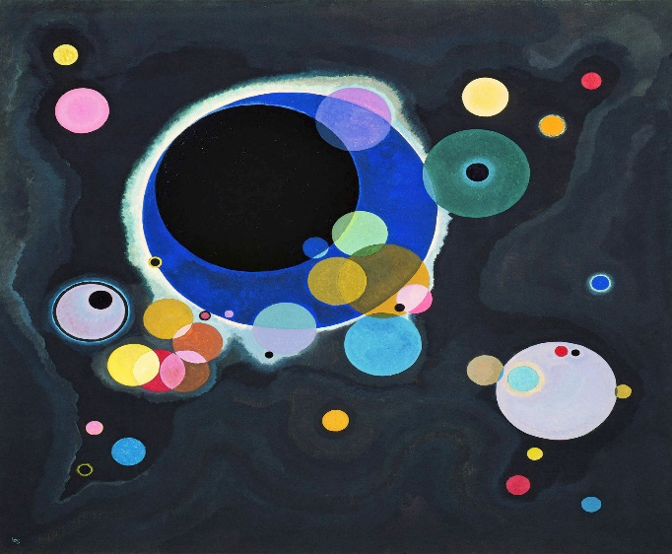  Choose your favourite 2d shape and create your own art whilst listening to your favourite happy song or music.  Extra Challenge  Create art using just hot or cold colours or bubbles. How many different circles can you use to create your masterpiece? |  | P.S.H.E  PSHE Safe Indoors and Outdoors  Who helps to keep us safe?  How can we help ourselves to keep safe?  What things could be unsafe in the classroom? What about at home?  What about outside - in the playground or in the park?  What makes things safe or unsafe?  Look at the book about Harold the giraffe who is being a safety detective. (Harold the Safety Detective).  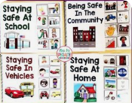  Can you explain what could, if not used properly, be unsafe in each picture? Who is responsible for looking after you? Can you do things to keep you safe from harm? Create a colourful safety poster ‘Hold on Harold’  Challenge  Make a booklet - ‘Staying Safe Manual’ or a safety poster that could be displayed in school.  Email your poster to our class email.  class2@leacofe.lancs.sch.uk
How to dance
- Move in time to the music.
- Everyone dances differently. Do what works for you!
- Tell everyone how good they are.
- Dance to different songs from the Lion King.
- Enjoy it!
Music & PE - The Lion King
Giraffes can’t Dance
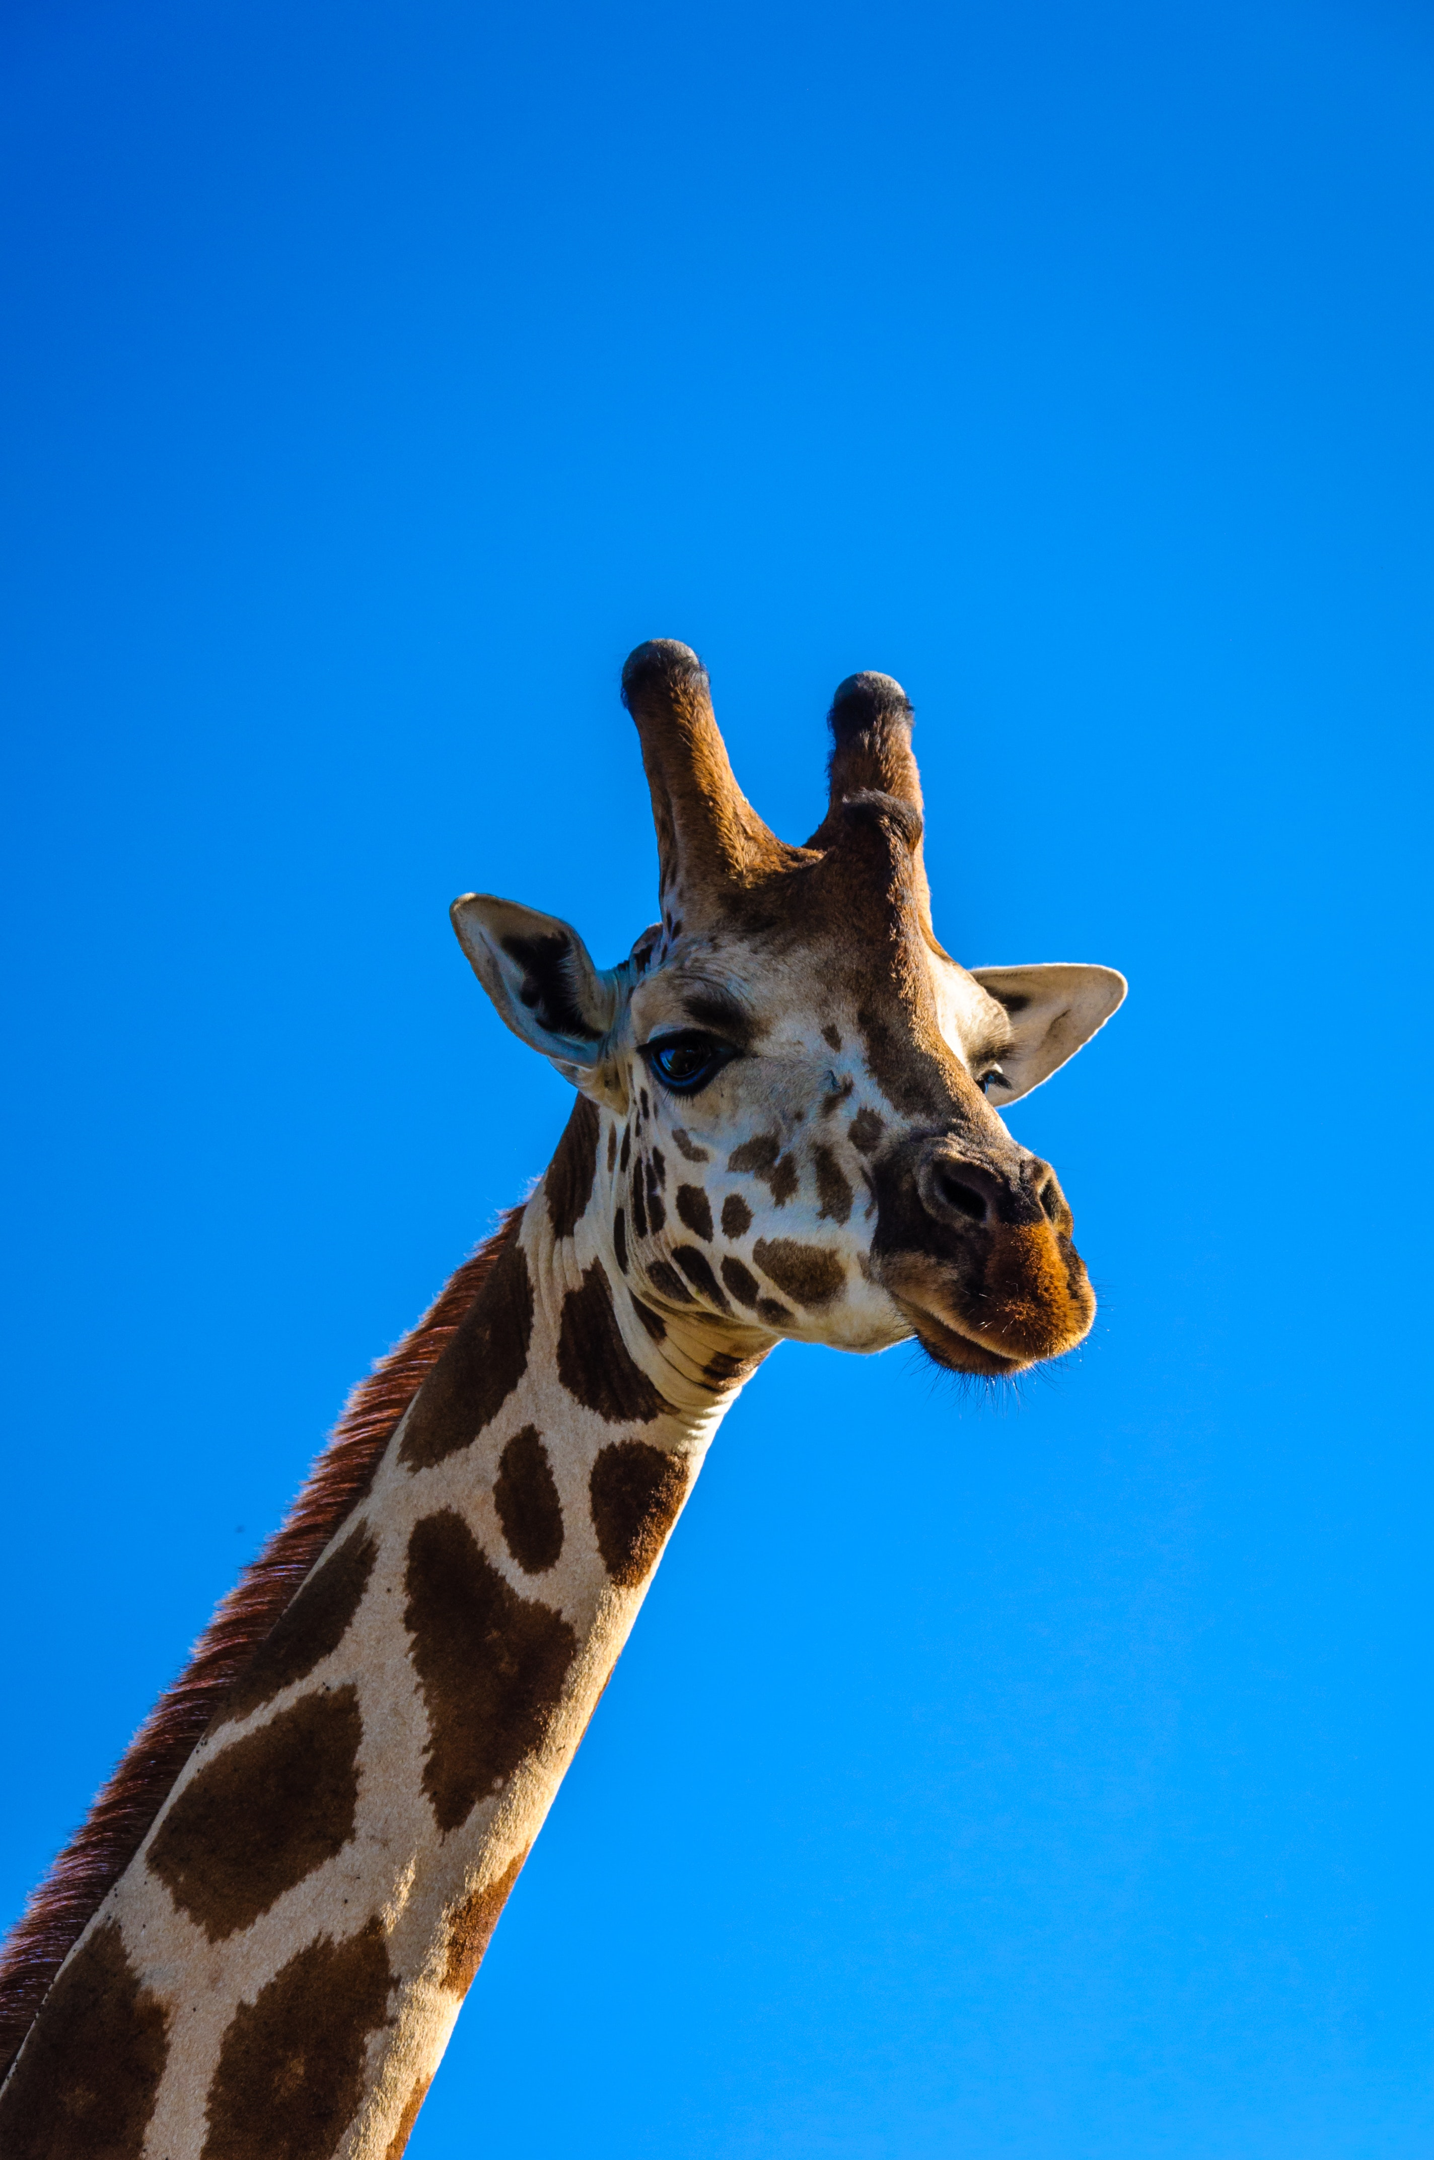

Share the story ‘Giraffe’s can’t dance’.
How does the giraffe move around?
https://www.youtube.com/watch?v=E92XNvCoeWo

Now it’s your turn!

Giraffe Freeze
Pretend to be a tall, elegant giraffe stretching up on tip toe. Play some music and dance. When the music stops, see if you can freeze like a giraffe. How many giraffe poses can you do?

Gallop, Stretch, Freeze
How might a giraffe move? Can you walk, bow, stretch and run like a giraffe? Ask someone to yell out ‘gallop’, ‘stretch’ or ‘freeze’. Move like a giraffe, listening out for the instruction – you should then move faster, slower or stop, bow and freeze.

Giraffe Moves
Work with someone to create a list of ways giraffes move. Think of a move for each one. Play some music and shout out each action.

