Maths Alive in 5! - Week 3 | White Rose Maths  This week we are exploring weight and measurement. If you have some balance scales you could use those. Or you could use your arms and hands as the scales! This week is all about using clear vocabulary to talk about and describe different measures.  Explore holding different objects in your hands. Use clear language to describe what you discover – heavy, light, heavier than, lighter than.  Fill cups with different amounts of liquid. What do you notice? Use the key vocabulary to talk about and compare each cup – full, empty, nearly full, nearly empty  Explore filling different sized containers. What do you notice? Which pot holds the most? Which pot holds the least? Key vocabulary – smaller, smallest, larger, largest, most, least.  Go on a hunt to find some objects that will fit inside a small box. You could go around your house or outside. Make sure you think about the size and length of each object you find. How many objects fit inside your box altogether?  Have a go at making your own playdough. Remember to measure out your ingredients carefully. Follow the recipe on the home learning section on the website. Have fun!  Extra challenge  You could make a set of balance scales using simple household objects.  DIY Balance Scales for Toddlers and Preschoolers – Go Science Kids  Do some baking using scales. Maybe you can find different sorts of measuring scales in your kitchen? Find out the difference between digital and mechanical kitchen scales.  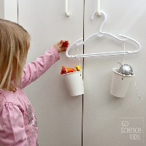 | English  This week we are looking at ‘The Little Red Hen’.  https://classroom.thenational.academy/units/little-red-hen-2e6d  Try to complete the first 4 or 5 lessons, where you can listen to the story, make up a song, write or draw a story map, and think about the characters in the traditional tale. Maybe you could act out the story using soft toys. It may need a new title though eg ‘The Big Blue Teddy’!  Extra challenge  Make your own story of ‘The Little Red Hen’. You could split a page in your home learning book into 4 sections and write a sentence for 4 different parts of the story. Or for a bigger challenge try and do 6! When you’ve written 4/6 sentences draw an illustration for that part of the story. Can you read your story to a family member?  Reading  Virtual School Library | Oak Academy (thenational.academy)  This site features a different author each week. There are videos to watch and stories to share. Be aware however that not each author will be suitable for Reception age children, so always check first. For example, this week is Jacqueline Wilson who is more suitable for older children.  Read daily using the Oxford Owl website using our class login. The site is experiencing a lot of traffic at the moment but is working hard to make it accessible to all.  https://www.oxfordowl.co.uk/  Username: recep19 Password: bamber  Phonics  Play the Phase 2 and 3 games on PhonicsPlay and https://www.phonicsbloom.com/  https://www.teachyourmonstertoread.com/ is an award-winning series of games that’s free to play once you’ve registered. I’m not for one moment suggesting that you have a ‘little monster’ at home :) There’s just no www.teachyourlittleangel.com as yet…
Phonics and Reading

On the Class Info - Reception section of the school website you will find a short video explaining how we teach phonics in school.
If you click on ‘Helpful Resources’ you will find some reading and phonics information packs from September. They will give suggestions for encouraging reluctant readers, and give strategies to work out unknown words. They explain the terminology of phonics, and give prompts for questions to ask to develop reading comprehension.
Design Technology Hit Your Target
I hope you enjoyed making your paper planes last week. Your new challenge is to make a plane that you can throw with accuracy. Make some targets to aim your paper plane at. You could draw targets on paper or fabric, or get creative and make them from recycled objects.
Start by setting up the targets and assigning points to each target. The smaller targets should have higher points because they are more difficult to hit.
Stand on a spot and throw 5 paper airplanes at the targets. You’ll receive points for each target you knock over. Happy Throwing! 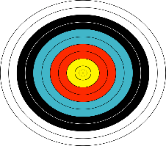 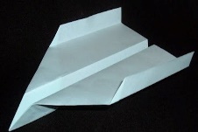
This Photo by Unknown Author is licensed under CC BY-SA-NC
This Photo by Unknown Author is licensed under CC BY-NC-ND
Expressive Arts & Design
In your English lessons you have listened to the story of ‘The Little Red Hen’. Now it’s time to act the story out! On the website are two ways to do this. You could make stick puppets by cutting out the characters and sticking them onto lolly sticks or pens. Or you could look at the pictures but draw your own. Alternatively, you could print out the masks and either wear them yourself or put them on some of your teddies! Try to act the story out, using an expressive story voice and using the language from the story.
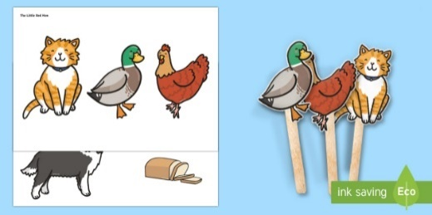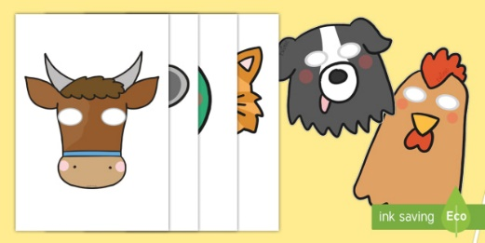
Music
https://www.youtube.com/watch?v=D9hCOrGEJ10
This week we are making our own music.
How many more instruments can you make to go with your shakers and guitars?
How about making a drum from a strong box, a large container, or a tin?
Can you make any other instruments?
Send in your photos – we’d love to see them! Listen to the music and play along with your instruments.
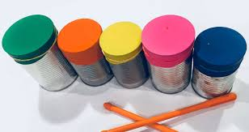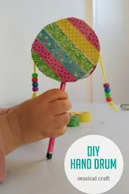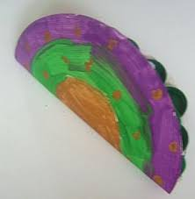
History
Last week you thought about a visit to a nurse and you learned a few things about Florence Nightingale. This week I’d like you to think about the work that nurses today do. Talk to your family about the different things a nurse does. Use this information to make a poster thanking nurses for everything they do. Maybe when it’s finished you could put it in your window to say ‘Thank you’ to our nurses in the NHS.

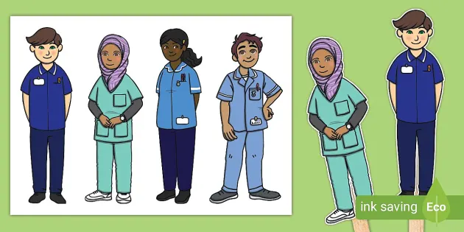
RE Stories Jesus heard
Listen to the story of Daniel in the lion’s den.
SPCK Bedtime Story | Daniel in the Lion's Den - YouTube
Talk about the story. Talk about Daniel’s bravery and his trust in God. Retell the story to somebody and talk about a time when you were brave. Draw a picture showing something brave you did. Who did you trust to help you through it?
Extra challenge
Make a collage lion. Will your lion be fierce or friendly? Write the name of your lion on your picture.
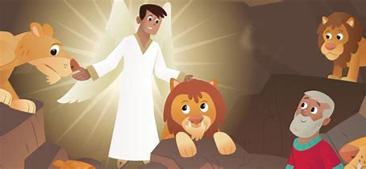
Outdoor Learning/Science
Go for a walk outside, in your garden or at the park. What can you see around you? Can you see any changes taking place with the plants or trees since last week? Are any plants starting to grow? Has the very wet weather changed things? Take pictures of any new growth, changes or animals that you see.
If you cannot see any new life yet, find out which plants are the first to grow.
Extra challenge
Maybe you could buy some daffodils from the supermarket and put them in a vase to observe the changes. You could take pictures as they bloom, or make a simple diary showing what happens.
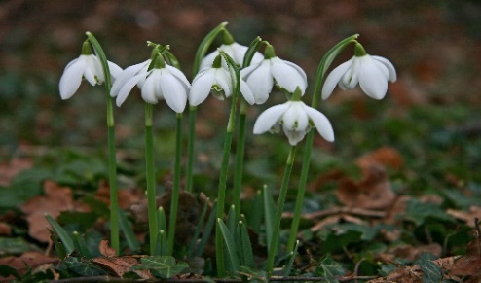
This Photo by Unknown Author is licensed under CC BY
This Photo by Unknown Author is licensed under CC BY-SA
P.S.H.E Rights and Responsibility
Taking care of something
What needs do we all share? Do we need to eat? Drink water? Can you think of more needs? Who is responsible for taking care of us? Does everyone in your family have the same needs? Do you help with anyone’s needs at home?
Watch 'The Pigeon Wants a Puppy' by Mo Willems about looking after things. https://www.youtube.com/watch?v=HiR1zuofXqw
Can you make a list of what a puppy needs to be properly looked after?
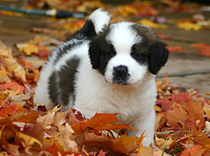
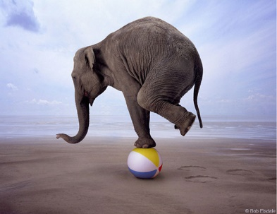
PE BALANCING CHALLENGE
Try and do a different balance each day!

How to Balance
1. Make sure you are looking forward.
2. Look at a fixed point in front of you.
3. Make sure you are holding your body in a strong position.
4. Make sure you are balancing on a flat surface.
5. Try to hold your balance for about 5 seconds.
This Photo by Unknown Author is licensed under CC BY-NC-ND

Balance that Balloon
Try to balance a balloon on different body parts e.g. your head, hand, foot, shoulder, arm. How many seconds can you keep that balloon balanced for?

How Long Can You Last?
Ask someone to time you while you balance on different body parts e.g. one foot, one knee, one hand or one foot. See how long you can balance for before you start to wobble.

Balancing Bridges
Ask someone to help you make different types of bridges; you can do this by leaning against one another or a solid surface. For example, put the palms of your hands together and lean towards one another; stand back-to-back and slowly move your feet out to make a bridge beneath you; or put the palms of your hands against a wall and walk your feet out - can you make a bridge so low that no one can get under?

Can't Push Me Over!
Create a balance e.g. stand on one leg or sit on your bottom with your arms and legs off the floor. Ask someone to try to gently push you over - can you remain balanced? Try again with different types of balances.

