Maths  Go on a number hunt around your house! See if you can find numbers from 0 to 10. If you can, take a photo of each one, print it out and see if you can place the numbers in the correct order.  Play the number game below. See if you can order the numbers correctly.  https://www.topmarks.co.uk/learning-to-count/gingerbread-man-game  Explore writing numbers to 10. You could pour some flour or rice onto a tray and have fun forming numbers in it. Maybe you could use pasta shapes to make the numerals.  Try to get into the habit of counting when you are out and about. For example: How many buses have we seen? How many lamp posts are on the street?  Look for shapes all around! Can you find squares, rectangles, circles and triangles? Talk about how many sides and corners they have. Are all the sides the same length? There are some videos to watch on the link below, and some worksheets to print out if you can. Try and complete Sessions 1, 2 and 3.  https://whiterosemaths.com/homelearning/early-years/light-and-dark-week-3 |  | English  Reading  We have our own class area on Oxford Owl. Follow the link below and then select My Class Login. On here you will be able to choose books to read, listen to stories and take part in activities around the text.  https://www.oxfordowl.co.uk/  Username: recep19  Password: bamber  Choose a book from Level 1+ and read it with your grown up. ‘Big Bad Bug’ has lots of words that you’ll be able to read by segmenting and blending the letter sounds.  Phonics  We have looked at lots of different letter sounds this year. See if you can play the Phase 2 Phonics games to remind yourself of all the phonemes we have learned.  https://learn.readwithphonics.com/parent/play-online  See if you can read a word by segmenting it into its letter sounds, and match it to the correct picture.  https://www.phonicsplay.co.uk/resources/phase/2/pick-a-picture  Writing  I hope that Santa came to visit you on Christmas Day! Draw a picture of some of your favourite presents. Try and write by yourself what the present was – I’m sure you’ll be able to write the letter sound at the beginning, middle and end. Don’t worry about spelling it correctly – listening carefully for the letter sounds is much more important!
Frosty Fingers  Investigate what happens when you leave an ice cube or an ice-lolly on a plate.  Explore and see what happens if you put them in different places around the house. Write or draw what you have discovered. | Snowflakes  How many different snowflake patterns can you make from different shaped pieces of paper? | Do you wanna build a Snowman?  Construct a snowman using cotton wool or other items you find at home.  How many different materials can you use? | New Year’s Resolution  Make a poster of your New Year’s resolution.  Are your New Year resolutions the same as anyone else in your family?
Winter Walk  Go on a walk and collect natural materials/objects to make a collage picture or make a sculpture outside and take a photograph.  Send it in – we’d love to see your creations! | Instruction writing  Write a set of instructions for something you have made this week at home.  Eg. Snowflakes  Collage  Snowman  Baking/Cooking | My Favourite Christmas Present  What did Santa bring you?  Draw a picture of your favourite Christmas present and write about why you like it so much. | Little Snowflake  Listen to the song Little Snowflake by Super Simple Songs  https://www.youtube.com/watch?v=tbbKjDjMDok  Can you sing along and make a snowflake dance?  Write a list of as many words as you can to describe a snowflake.

Workout of the Week – SPELL OUT YOUR NAME!
Using all the letters of your name, complete the workout doing the exercises at the side of each letter with the specified number of repetitions. Try to do it as quickly as possible, with as little rest as you need, BUT be careful not to get too excited and hurt yourself or others. Remember to warm up before you start and cool down at the end.
Do it each day and try to beat your time. Challenge your family to do their name exercises as well. Enjoy!!!
Had fun with this? Why not make up your own SPELL OUT YOUR NAME exercise challenge?
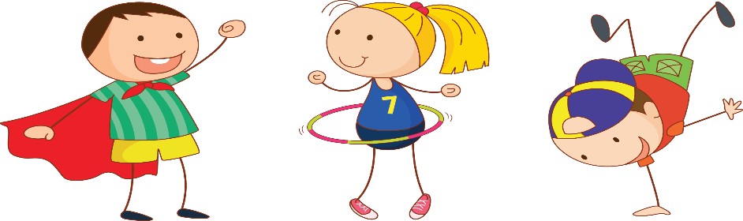

A : 10 HOPS | N: 10 BUNNY HOPS
B : 10 BUNNY HOPS | O: 20 HOPS
C: 10 SKIPS | P: 15 STAR JUMPS
D: 15 STAR JUMPS | Q: COMMANDO CRAWL FOR 10 SECS
E: 5 TUCK JUMPS | R: 10 SKIPS
F: MARCH ON THE SPOT FOR 30 SECS | S: BALANCE A TEDDY ON YOUR RAISED KNEE FOR 10 SECS
G: DO A SILLY DANCE FOR 30 SECS – CHALLENGE MUM! | T: 10 TUCK JUMPS
H: RUN ON THE SPOT FOR 10 SECS | U: BOUNCE A BALL FOR 15 TIMES
I: BOUNCE A BALL 10 TIMES | V: JOG ON THE SPOT FOR 30 SECS
J: BALANCE A TEDDY ON YOUR HEAD (20 SECS) | W: BALANCE ON EACH FOOT FOR 10 SECS
K: BALANCE ON 1 FOOT FOR 10 SECS | X: 15 STAR JUMPS
L: HOP, SKIP AND JUMP 3 TIMES | Y: DO A SILLY DANCE FOR 30 SECS – CHALLENGE DAD!
M: MOVE LIKE YOUR FAVOURITE ANIMAL FOR 30 SECS | Z: 5 TUCK JUMPS

