Hi again Class 5. I hope that you are all managing your Home Learning ok and are managing to do a few other nice things as well to compensate for us not being together in school as normal. Remember that some of the tasks I set are open ended and can stretch over more than one week. The aim is that you do AT LEAST 3 hours of learning a day but this can include extended reading, TTRS, extra research or exercise (which is really important for body and mind)

Please take care of yourself and your family and get in touch to show me your work and ask any questions. Shine brightly!

|  |  |  |
| --- | --- | --- |
| **English** | ***Focus Text – The Wizard of Oz***  After looking at extreme weather last week, this week we are going to innovate a new character for our own chapter of The Wizard of Oz; a character who Dorothy meets once she has been transported to Oz by the storm of your choice (which you researched last week!)  **Read the character introductions** from several classic texts which are on Attachment 01. Some of these you will recognise as we looked at them in class. Highlight any adjectives or phrases which describe the main character.   * Lesson 1 – Write a section of information describing the Scarecrow using Point and Evidence as we have done in class. *I think the scarecrow is……. I know this because…*…… Remember that we need to be **inferring** information as well eg if it says a character is pale and weak, we may infer that they are underfed, poor, not looked after or cared for etc. Please use neat handwriting, paragraphs if necessary and powerful vocabulary at all times. Check any unfamiliar spellings. * Lesson 2 – Innovate you own Wizard of Oz character which needs to be ‘fixed’ in some way. Draw inspiration from characters such as Pinnocchio, Punch and Judy, Toy Story, Muppets etc. Draw your character and write a short description or detailed labels of what their character is like. What is your character ‘lacking’ that means they need help from the Wizard? * Lesson 3 – For today, we are going to create our own free verse using the model below and an awareness of antonyms(opposites). Read the human free verse on this slide and then using the ‘antonym’ version of Pinnocchio, create a similar poem for the character you innovated yesterday * Lesson 4 – Today we are going to begin using our work from last week and the beginning of this week, to start writing our own ‘ lost chapter’ from The Wizard of Oz.   Today, I would like you to describe the storm of your choice and how that storm resulted in Dorothy being transported to Oz. Think about the video clip we watched of the tornado picking up the house and how the main characters felt and reacted.  <https://www.youtube.com/watch?v=RQWSh7Db-_E>  Use this as a model for your opening. Remember to use action, description and dialogue as we have practised in class. I am expecting approximately ¾ side of A4 for this please  Lesson 5 – Today I would like you to write the next section of your chapter focussing on Dorothy meeting your new character. Think about when Dorothy met the scarecrow  <https://www.youtube.com/watch?v=yejtZgzB5Ik>  Describe the meeting between Dorothy and the new character (speech), including a detailed description of the character (lots of descriptive language – what does your character look like, what are they wearing, how do they move, how do they speak, where are they stood), the character asking to accompany Dorothy to Oz to ask the Wizard for something, and how Dorothy reacted to them. | |
| ***Reading***   * Daily reading is a must. At least 10 minutes is needed to maintain and continue the progress you have made.   I have created an account on [www.oxfordowl.co.uk](http://www.oxfordowl.co.uk). It is a free resource that gives a range of reading books that follow the school reading bands.  **Username: class5lea**  **Password: shine**   * When you have finished a book, complete a book review. I have included an example of how you might do this at the end of your home learning. * You may also complete some of the activity pages in your Home Reading Diary * **EMC** –I am attaching our Reading Journal activity sheets (**Attachment 02**) which we complete in class – please try and complete some of these for the books you are reading at home. Mix the activities up so that you are not always choosing the ‘drawing’ ones! | ***Writing***   * You need to be writing every day to maintain the standard and keep the muscles in your hand working. This could take a variety of ways: * the home learning you’re doing * specific handwriting practice * writing a letter to me. * Write your own story * Include the grammar foci: fronted adverbials, speech, ed openers, similes and so on   Write in paragraphs and include chapters |
| **Maths** | ***Maths***  I am including video links to the White Rose Maths teaching videos. These should helpfully guide the children through the learning process for each unit covered. The corresponding worksheets are available on the school website on our Home Learning class page.  **This week we are covering Geometry – Position and Direction**  <https://whiterosemaths.com/homelearning/year-6/week-13-geometry-position-direction/>  If you wish to extend your learning further in this area of Maths, **Attachment 11**, has some additional questions for you to work through. **Attachment 12** has the answers so that you or your adult can check how you have got on!  **Additional Maths Activities**  TTRS - <https://play.ttrockstars.com/auth/school/pupils>  Arithmetic - <https://myminimaths.co.uk/year-6-arithmetic-practice-papers/>  This site has lots of arithmetic style questions to keep your brain switched on – scroll down and click on **WEEK 3** practice paper – have a go at the questions and then check them in the answer section.  \*\*See below for a few extra short Maths activities you can try (Ski Run and varied Arithmetic Questions).   * Ski – Run - <http://www.mathsbox.org.uk/re/sandc/srns/sr2%20(Web)/html5.html> | |

|  |  |
| --- | --- |
| **RE** | Shepherd tending his flock of sheep and goats, Rajasthan, India Stock Photo  - AlamyI wonder what you think this shepherd does all day in order to look after his sheep?  I wonder if he really does know every one of his sheep?  I wonder what he would do if one of them went missing?  Choose to read either Psalm 23 from the Old Testament or The Parable of the Lost Sheep (Luke 15:1-7) in the New Testament.  Create a picture that either illustrates Psalm 23, or the moment the shepherd finds his sheep in the parable.  Watch, and then write a script for, the Max 7 Lost Sheep video  <https://youtu.be/tyWZeOlaRo4>  Listen to Stuart Townsend singing his interpretation of the 23rd Psalm <https://youtu.be/pN4tPkX0MG0>  Why does he say that he will trust in God alone? What has God done that makes the person who wrote the Psalm want to put their trust in God?  EMC - Based on the evidence in the Bible passage you read, write a brief job description for a shepherd. Jesus describes himself as being the good shepherd. Would he fulfill your job description? Why? |

|  |  |
| --- | --- |
| **Science** | **Our unit is Earth and Space**  Introduction of the topic ‘Space’  How Can You See a Satellite View of Your House? - Universe TodayDo you know any facts about Space? What do you know already? What would you like to find out? What questions would you like to answer?  Record in your books as a spider diagram/concept map and a set of questions which you can return to at the end of the topic.  Watch some video clip/photos/satellite displays of earth.  Draw a labelled diagram of Earth as on a satellite picture.  It is only within the last 50 years that we have photographic evidence from space about the Earth being spherical.  How do you think people might have known the Earth was round before this?  Look at the clip about the Earth being round.  [**http://www.bbc.co.uk/learningzone/clips/how-do-we-know-the-earth-is-spherical/2457.html**](http://www.bbc.co.uk/learningzone/clips/how-do-we-know-the-earth-is-spherical/2457.html)  Put the Earth, Moon and Sun in order of size.  You could do this practically by choosing from a range of spheres in your house e.g. beach ball, football, tennis ball, ping-pong ball, marble, peppercorn, coriander seed, tiny beads.  Draw a labelled picture of the Earth, Moon and Sun, being conscious of the relative sizes and the position relative to each other. |
| **Art** | **Choose another one of the following activities or continue with one which you have already started, which link well to our work on Earth and Space – this may become a project style piece which you work on for the duration of lockdown when you have some ‘creative’ time!**   * Create artwork to represent what Earth looks like from the International Space Station * Create a papier mache planet. * Design a new space suit that is fashionable. * Create a model of the solar system |
| **Geography -**  **Extreme Weather** | Last week, you should have looked at different kinds of extreme weather such as tornados  This week I would like you to create a glossary of extreme weather types following the **Success Criteria** below:  1. List all the extreme weather types that you can think of. This video may help!  https://www.sciencekids.co.nz/videos/weather.html  2. Now arrange these different extreme weathers into alphabetical order  3. Now, research using books, internet etc what these extreme weathers actually entail  4. Write a definition of the extreme weather type – DO NOT COPY DEFINITIONS – WRITE IN YOUR OWN WORDS!!  EMC – Have you any experience of any of these types of weather? How did it feel to be part of it  Why do you think, weather is becoming more extreme eg more flooding etc |

|  |  |
| --- | --- |
| **PE** | ***Move***  Lancashire School GamesChange4Life – 10 minute moves  Complete one of the Zootropolis themed activities at day: <https://www.nhs.uk/10-minute-shake-up/shake-ups?filter=zootropolis>  Complete a Just Dance video each day (trying to imitate the video) <https://www.youtube.com/user/justdancegame/videos>  ***Learn***  Skill to learn and master – Jump <https://lancashireschoolgames.co.uk/learn-2/>  ***Challenge***  Long jump and triple jump <https://lancashireschoolgames.co.uk/long-jump-and-triple-jump-challenge/> |
| **PHSE** | **Solve the Friendship Problem - Attachment 13**  People sometimes call into television programmes or radio shows or write into magazines or websites with problems that they’d like some help or advice with. You are going imagine that you’re working on an advice show on the radio  Activity – You are going to look at some friendship problems and think about what advice to give. For each problem you need to think about these things  1. Does this sound like a positive, healthy friendship?  ***How Good Friends Are Good For Your Health : Shots - Health News : NPR***2. Does it sound like a balanced friendship?  3. What advice can we give that is respectful and assertive?  First, discuss what each question means.  Look at the Solve the friendship problem Activity sheet (Attachment 13) Choose 2 or 3 to discuss, considering the three questions above Then write your advice and then present it as if you were on the radio.  Think about how this might sound e.g.  “We’ve had an e-mail from Sam in Leeds who says…..”  “So, what advice would you give Sam?”  “Well, Sam, thank you for writing in…..” |
| **Picture News** | ***C:\Users\boltonr\AppData\Local\Temp\Temp1_Primary Picture News Resource England - 11th January - Soldiers.zip\Picture News Poster - 11th January.jpg*** Armies in the UK and all over the world have played a key part in supporting governments and helping in many ways throughout the pandemic and it’s likely that their role will continue in 2021.  In early autumn, the military helped to organise mass testing in Liverpool. In December, 1,100 military personnel were sent to help thousands of lorry drivers spending Christmas Day stranded at Dover. Most recently, the Army have been helping secondary schools and colleges in England to set up mass coronavirus testing for their pupils.   * A typical day for a soldier involves working on their base, using their trade skill or developing new ones and fitness. Why do you think it is important that soldiers take part in daily fitness sessions? * • The first role of the Army is to protect the nation and they are always ready to serve. The Army is also involved in preventing conflicts, dealing with disasters and fighting the nation’s enemies. How important do you think it is that we have an Army? |

**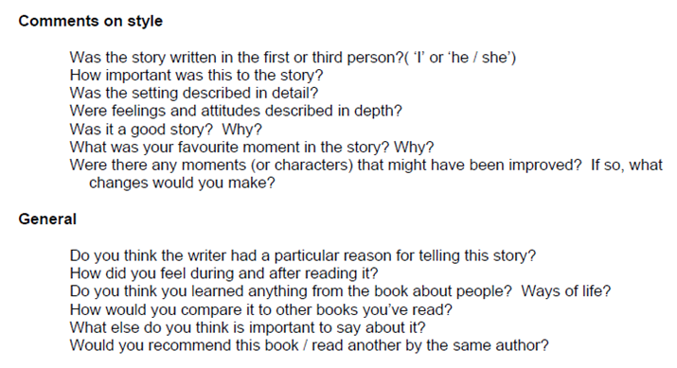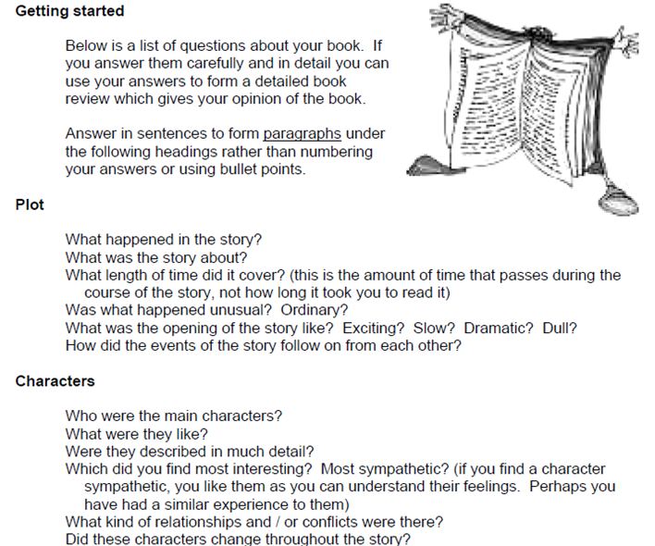How to write a book review**