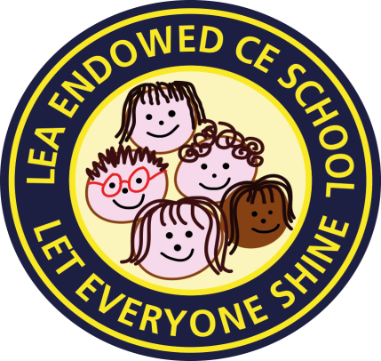

Lea Endowed CE Primary School

Newsletter No 15

Friday 29th January 2021

This week our theme is Thankfulness

**“Let your light shine.”** Matthew 5:16

Dear School Family,

Just a few thoughts following another announcement that schools will stay “closed” until at least 8th March…

**To all our children**, *(please read this to your child if they can’t read it themselves)*

I want to let you know that I am missing you SO much! Unfortunately, for many of you, school will have to stay closed for a few more weeks. Remember, you are still the same special person whether you’re at home or in school. You can still laugh, learn and love, and go the Extra Mile in many different ways. Try to remember that most of your parents are not school teachers (they teach you hundreds of other important things about life every day) and many of them have their own work to do at home, so I’m asking that you think of all the ways you can shine at home right now. Be kind and respectful to your mums, dads and anyone taking care of you! Remember this is a really hard time for them too. Try your best with your Home Learning (the teachers have worked very hard to make it just right for you **and** your mums and dads) but you **MUST** **NOT** worry about it. **Show** your grown-ups you love them by being respectful and trying to do little things around the house to make a positive difference for your family (a smile and a hug can transform the day). Not only will this make you feel better but just watch how much of a difference it will make to them too. I’d love to hear how you’ve made your grown-ups smile this week.

**To all our parents and carers** ….and breathe!

I know that for so many of you, the latest announcement for schools remaining closed for longer, will have been a huge, if not unexpected, blow. Please know that your home must remain just that, **a home** - the main thing you want your children to remember, when we’ve come out the other side of all this, is that you loved them throughout, and you gave them a safe haven in a chaotic world. This week, in an open letter, to the Nation, Archbishops Justin Welby and Stephen Cottrell invited everyone across England – whether they have faith or not – to pause, reflect on the “enormity of this pandemic” and to pray.

I am sending a copy of the letter for you to read. You may feel you would like to be a part of this call.

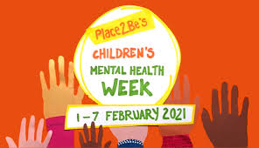

Continued

**CHILDREN’S MENTAL HEALTH WEEK**

**Next week 1st-7th February is Children’s Mental Health week. Mental Health and Wellbeing** has never been given so much coverage in the media, as we all become increasingly aware of how the pandemic is affecting our wellbeing in different ways. Next week, in school and as part of Home Learning plans, we are having a focus on Children’s Mental Health. On Wednesday 3rd February we will be having an **Inside out Day.** We will remember that it’s good to talk about our feelings and share what is on the inside, with others, especially if we have worries, fears or concerns. Please encourage your child (at home or in school) to wear something inside out and have those important conversations about our feelings. Of course, this is invaluable for adults too!



**Helps for Parents**

We have now added **Vocabulary Dictionaries for KS1 and KS2** to our website. These break down the many terms you may come across as part of the children’s learning in English.

A Maths version should be live on the website next week.

You may find the Oak Academy’s Free Virtual Library helpful in keeping your child interested in reading.

The Picture News tab on the website is updated weekly with current events being shared in a variety of ways for discussion and activities. We have also recently signed up to the Early Years’ version of this resource which is geared towards our youngest children.

I hope you find some of these resources as helpful at home, as we do in school.

**STAYING IN TOUCH**

Please look out for the weekly welcome videos from the teachers on the Class Home Learning areas.

If your child hasn’t joined in with the weekly Class Zoom sessions, why not encourage them to take part. If you are having difficulty connecting to these, please just get in touch and we will try our best to help.

Thank you

With love and prayers,

C M Seagrave

**For the latest government Covid advice for parents and carers please see the link below:**

[**What parents and carers need to know about early years providers, schools and colleges**](https://www.gov.uk/government/publications/what-parents-and-carers-need-to-know-about-early-years-providers-schools-and-colleges-during-the-coronavirus-covid-19-outbreak?utm_medium=email&utm_campaign=govuk-notifications&utm_source=80396361-8641-4207-9c25-8ef0dd1ed9b8&utm_content=immediate)

Remember, there is a wealth of useful information, advice and guidance on Online Safety, Mental Health, Covid Health etc on our website