**Fortnightly Class 2 Newsletter**

Come to school – it’s really cool!

Be on time – it helps you shine!

**Friday 23/05/2025**

Your child’s learning is very much a partnership between home and school so if you have any concerns at all please telephone the school office, come and see us or contact via email.

**Staff Contact Details**

**Year 1**

[a.lucarelli@leacofe.lancs.sch.uk](mailto:a.lucarelli@leacofe.lancs.sch.uk)

a.bamber@leacofe.lancs.sch.uk

**Year 2**

[s.ramsay@leacofe.lancs.sch.uk](mailto:s.ramsay@leacofe.lancs.sch.uk)

**School Office Tel: 01772 729880**



**Save the Date!**

**23rd June-** Year 1 Class Worship @10:40All are welcome

**Wednesday 9th July** – Y1 & Y2 Trip to Blackpool Tower.

**Friday 11th July** – ‘Bend the Rules’ Day

**Sunday 13th July** – Leavers’ Service @ St Christopher’s 10.30a.m

**Monday 21st July**- Disco 5-6pm KS1



**Class Open Door**

Please, feel free to visit classrooms and ask any questions you may have.

**Year 1**

Monday 3:20pm – 3:40pm

**Year 2**

Monday 3:20pm – 3:40pm



**Class News**

**In Year 1…**

We have had a great start to the final term in Year 1. The children enjoyed telling us about what they have been doing in the half term break. The children impressed us during their Phonics Screening and all of them tried their very best!

We had a fantastic Sports Day and worked hard in all the different activities. Well done to Rowan team for winning overall 😊

We have begun learning about Jesus and the world he grew up in as a child. We have talked about the how the clothes were different to the ones we wear now. We talked about how the houses are very different such as the stairs being on the outside and how they slept on the floor on mats. We talked about how people travel to holidays now and compared it to how Jesus travelled to Jerusalem. Next week, in RE, we are going to try some foods that Jesus would have eaten as a child. Please see the letter that came home on Wednesday.

**In Year 2 …**

We have had a super start to the final term of school and have come back ready to learn.

We have been looking at poetry these last few weeks and have been creating our own animal riddles. We have been looking carefully at figurative language and recognising words that rhyme within poems.

In Maths we are looking at time and learning how to tell the time to the hour and how many minutes are in an hour. Please continue to practise looking at clock faces and reading the times with your child.

We loved our trip to St Christopher’s this week to learn about why the church is a special place for Christians. We explored and identified features of the church building.

We had a fantastic Sports Day and all tried our very best at each event!

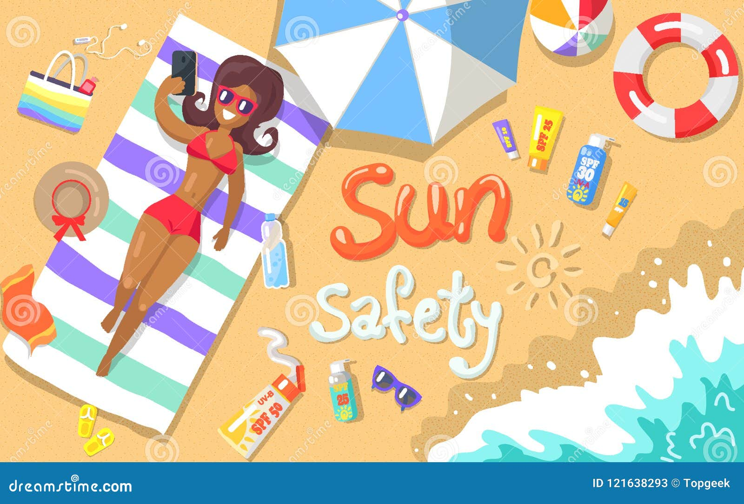

*Please see the following page…*

**Certificate Winners**

**Year 2 Year 1**

**Curriculum Awards**

Arthur- for an excellent attitude and working hard on our visit to Church.

Xavier- for following instructions and always listening carefully in class.

**Christian Value/Diamond 9 Awards**

Logan- for challenging herself and working independently.

Samuel- for offering unique answers in RE discussion and making great comparisons between our world and Jesus’.

**Star Write**

Emily- for a thoughtful recount of our visit to Church.

Anna- for a fantastic recount of Sports Day.



***If***



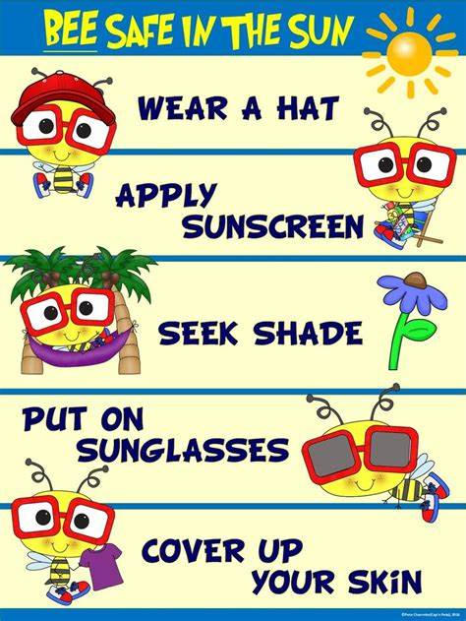

As the weather is currently a lot warmer, please ensure your child has a hat, sunglasses, sun cream and a water bottle in school so they can keep hydrated.

Thank you.

**Uniform**

Many of you will already be thinking about school uniform, and preparing for the next school year in the coming months.

Please remember to check our school website and the uniform list **before** you purchase and uniform, shoes or trainers for PE.

We respectfully ask that parents keep to our uniform code, and please name all items of clothing and equipment that comes into school.

As the children wear the same, if your child misplaces an item, it is very difficult to track down a missing item of uniform without a name. There over one hundred and forty children all wearing the same thing!

Do check out the ***‘Uniformd’*** platform for a more cost effective and environmentally friendly way of purchasing school uniform for your child.

A flyer with more details about this can be found on our school website in the Parents section.

SAVE MONEY - MINIMISE WASTE - RAISE SCHOOL FUNDS

Wishing you all a restful half term.

*Mrs Ramsay, Mrs Lucarelli & Mrs Bamber*