Hi Harrison, Jake, Kieran, Davy-Jae, Tyler, George, George, Ryan, Ollie, Alfie, Jake, Evie, Ethan, Jack, Faith, Lewis, Jensen, Lottie and Archie!
Happy New Year! Well this wasn’t what I was expecting. I was so looking forward to hearing about your Christmas holidays, if you’d enjoyed the snow, presents you’d received, and memories you’d made. As it is, we’ll have to do that some other way, some other time. Here is the Home Learning for the next three days. I have tried to give you a balance of activities from all the subjects we would be doing in school. Ideally, you should be doing learning for at least 3 hours a day, so why not do English, Maths and one other subject a day. Take photos of your work and email them to me. I want to see the learning you’re getting up to. If you don’t get all this work done, don’t worry – I have given you plenty to keep you busy here!
As always, LET YOUR LIGHT SHINE! We love you all lots. Stay safe and God bless. Mrs Bolton x
English | Focus Text/stimulus - Extreme Weather  Extreme weather clips for gathering content  https://www.youtube.com/watch?v=oWIx3Erswh8  https://video.nationalgeographic.com/video/101-videos/00000165-c429-de15-afef-c73da3c90000  Book: Infinity: Storm - You are able to read an extract of this book at https://www.lovereading4kids.co.uk (you need to become a member – but it’s free!) I have also included the extract as an attachment (1)  Hurricane Hideout poem – see attachment (2)  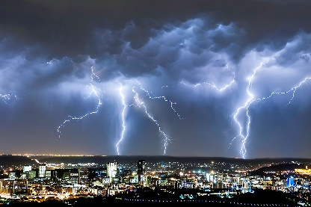  - Watch the clips of different extreme weather –List as many words and phrases linked to the weather as possible.  - Can you extend these words into exciting noun phrases? Think carefully about your vocabulary choices  - Can you up level the words using dictionaries and thesauruses or Word Hippo – this is free to access  - Do your own research on a type of storm – sandstorm, hurricane, typhoon, snowstorm, electric storm etc  - Imagine you are a storm chaser and have chased the storm heading for your main character. Write a report detailing your account of the storm and what happened to your character.  - Read Hurricane Hideout poem - Innovate to create your own poem based on a new storm.  Sneak in grammar skills taught: synonyms and antonyms, repetition, alliteration, extended noun phrases etc. Sort, choose and link ideas so that poem is cohesive and not merely a selection of random words/phrases
 | Reading  - Daily reading is a must. At least 10 minutes is needed to maintain and continue the progress you have made.  I have created an account on www.oxfordowl.co.uk. It is a free resource that gives a range of reading books that follow the school reading bands.  Username: class5lea  Password: shine  - When you have finished a book, complete a book review (you can find these easily with a Google search). Try to include: your favourite part of the story, your opinion about the story, how you could make it better, a quiz about the book, a drawing of the main character and label them | Writing  - You need to be writing every day to maintain the standard and keep the muscles in your hand working. This could take a variety of ways:  - the home learning you’re doing  - specific handwriting practice  - writing a letter to me.  - Write your own story  - Include the grammar foci: fronted adverbials, speech, ed openers, similes and so on  - Write in paragraphs and include chapters
Maths | Maths  We will normally be accessing the White Rose Hub Maths as we did during the previous lockdown. These comprise of video lessons and worksheets linked to that day’s objective.  However, with this week only being a partial week of learning, I am setting you some ‘SATs’ style questions linked to Sequences of Numbers. I am including the booklet as an attachment (3), but if you are unable to print this off to complete, then please write your answers on paper, making sure you number the questions. If you take a photo of your answers and email them to me, I can see how you have got on!  Additional Maths Activities  TTRS - https://play.ttrockstars.com/auth/school/pupils  Arithmetic - https://myminimaths.co.uk/year-6-arithmetic-practice-papers/  This site has lots of arithmetic style questions to keep your brain switched on – scroll down and click on WEEK 2 practice paper – have a go at the questions and then check them in the answer section.  **See below for a few extra short Maths activities you can try (Ski Run and varied Arithmetic Questions).  - Ski – Run - http://www.mathsbox.org.uk/re/sandc/srns/sr2%20(Web)/html5.html  - Try this Speedy Challenge – Tricky – Bronze, Trickier – Silver and Trickiest - Gold  BRONZE Your working out:  1) 186 437 – 36 208 =  2) 3612 ÷ 12 =  3) 5³ =  4) 45.6 – 12.05 =  5) 20% of 3400 =  SILVER  1) 17.6 x 8 =  2) 13.451 x 1000 =  3) 1/5 ÷ 8 =  4) 25 ÷ (12 - 7) =  5) 65% of 4000 =  GOLD  1) How many seconds are there in 6 minutes?  2) How many hours are there in 5 days?  3) n + 75 = 400 n = ?  4) What is the size of ONE of the angles in an equilateral triangle?  5) 5/7 of 6300 =  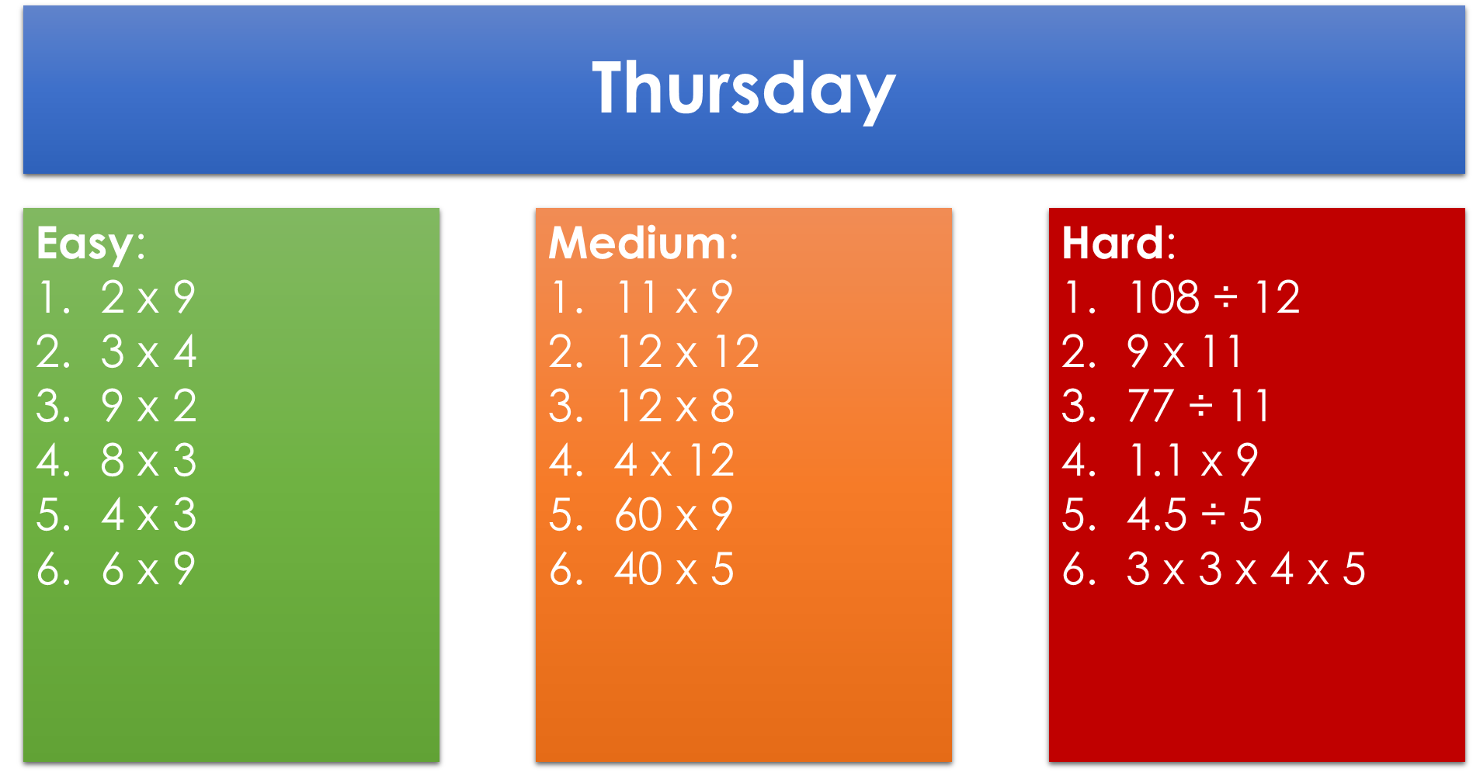

RE | 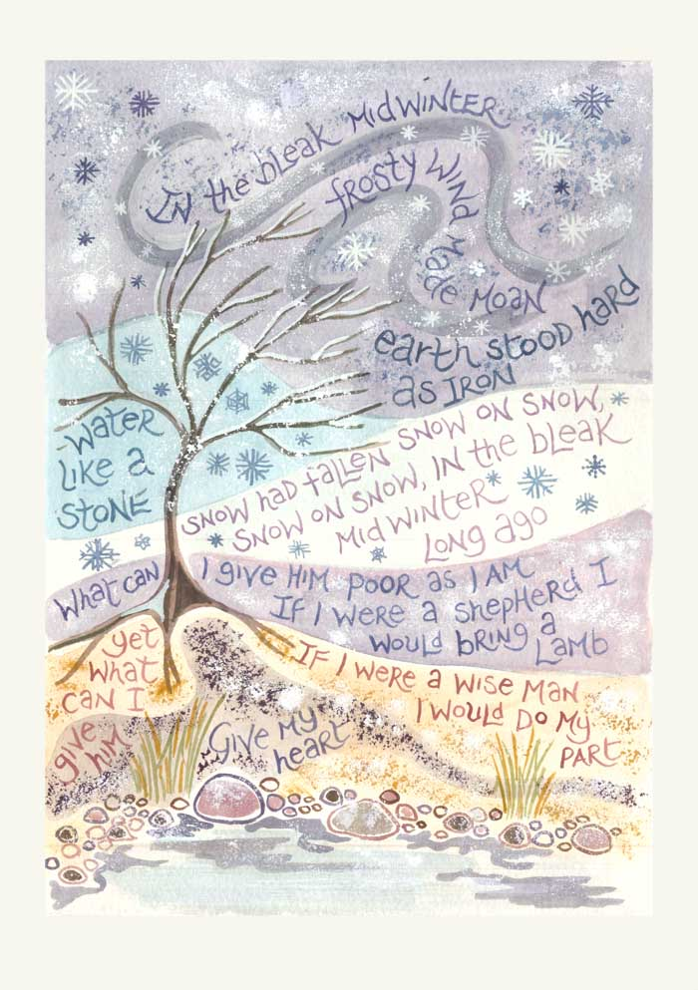  Epiphany  Today, Wednesday 6th January, is Epiphany. This is when we celebrate the Magi visiting the new-born Jesus.  I have included some questions for you to answer and then some activities based on this celebration.  - Why do we assume three Wise Men visited Jesus?  - Whose gospel account records the visit of the Magi?  - Who did they visit first? Why did they not go back?  - What do the three gifts represent? (Gold, frankincense, myrrh)  - If you were a Wise Man, what gift would you bring for Jesus? Why?  - Here is some artwork for the carol ‘In the Bleak Midwinter’ by Hannah Dunnett. What do these words tell us about the gifts that Jesus should receive?  Activities (complete at least 2)  - Create your own Epiphany artwork (see the example).  - Create your own star for the Wise Men to follow.  - Make a crown for the ‘Kings’ to wear.  - Mexicans eat Rosca de Reyes– search the recipe and have a go at making it!  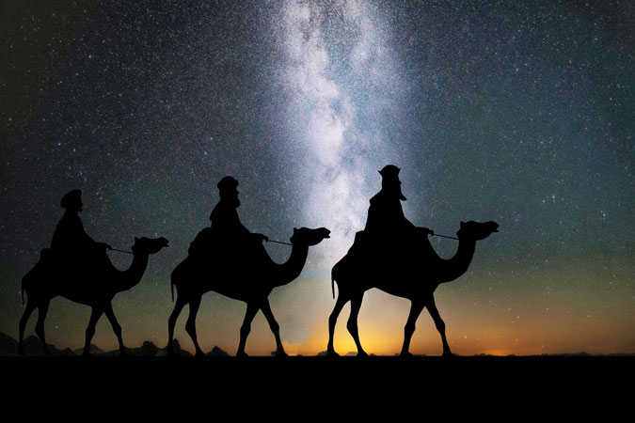

Science | Our unit is Earth and Space  As an introduction to this topic, I would like you to work on producing a simple fact file on one of the 8 planets.  This could be done on paper or on the computer and should include text and pictures/images to back up your research. Either way, you must address the following points:  - The distance of their planet from the Sun.  - The planet’s surface temperature.  - What the planet is made from.  - If it has any moons and if so, how many.  - How long it takes to rotate on its axis once – the day length.  - How long it takes to orbit the Sun – the year.  - One additional key fact or interesting point about that particular planet.
Art | Choose one of the following activities which link well to our work on Earth and Space – this may become a project style piece which you work on for the duration of lockdown when you have some ‘creative’ time!  - Create artwork to represent what Earth looks like from the International Space Station  - Create a papier mache planet.  - Design a new space suit that is fashionable.  - Create a model of the solar system
Geography -  Extreme Weather | - Everything we do is determined by the weather. How many different words can you think of to describe the weather and phenomena associated with the weather?  - What is climate? Share your ideas with a family member, then go through the explanation on the slides. Attachment (4)  - Different areas of the world experience different climates and conditions depending on where they are. See the world map on the slides.  - Where would you expect the hottest countries on Earth to be? Why?  - Where would you expect the coldest places to be? Why? Read through the explanation for why some areas are hotter and colder than others.  - https://www.bbc.co.uk/bitesize/clips/zr7hyrd  - Go through the information about the hottest and coldest places in the world, as well as other extreme conditions in other areas, such as the wettest places, driest places and ‘Tornado Alley’.

PE | Move  Change4Life – 10 minute moves  Complete one of the Zootropolis themed activities at day: https://www.nhs.uk/10-minute-shake-up/shake-ups?filter=zootropolis  Complete a Just Dance video each day (trying to imitate the video) https://www.youtube.com/user/justdancegame/videos  Learn  Skill to learn and master – Jump https://lancashireschoolgames.co.uk/learn-2/  Challenge  Long jump and triple jump https://lancashireschoolgames.co.uk/long-jump-and-triple-jump-challenge/

Picture News | 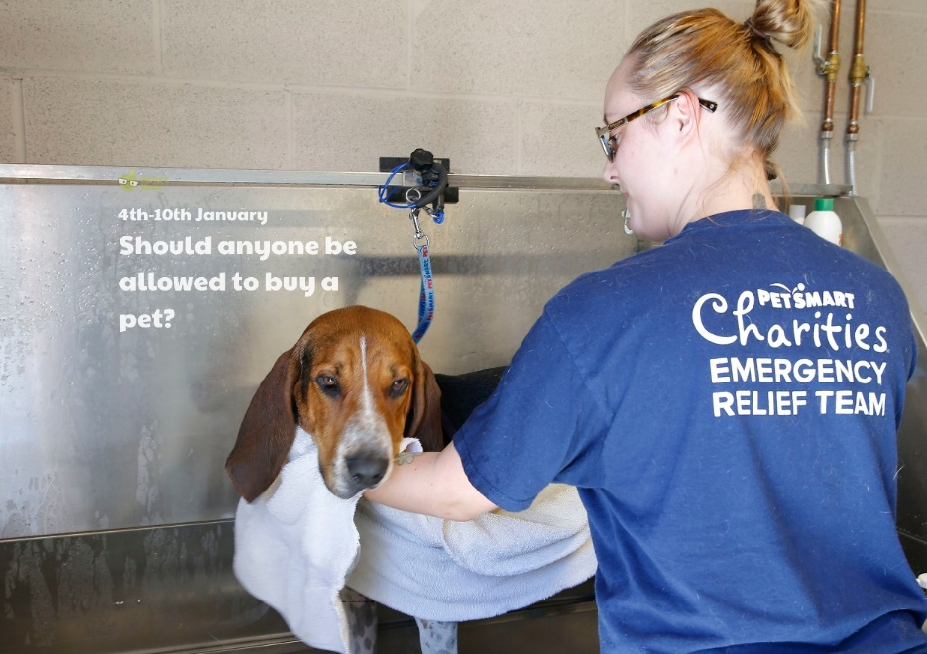  It is thought that thousands of pets were 'panic bought' at the start of the first lockdown. The Battersea Dogs and Cats Home charity have warned that the number of dogs abandoned over the next five years could increase by 27%. The charity, which rehomes animals in London and the surrounding area, surveyed 2,000 dog and cat owners who acquired a new pet during the national lockdown. It found 31% had done so despite not having considered getting a dog or cat before.  - Do you have any pets? If you do, do you enjoy being a pet owner? How do you take care ofyour pet? Is it a lot of work? If not, would you like to own a pet?  - Why do you think lots of people may have bought pets at the start of the lockdown period?  - Do you think that there should be age restrictions or other rules on who can buy pets?  Task 1  Plan and write a letter to an animal charity such as the RSPCA or Battersea Dogs and Cats charity to thank them for the work they do with animals. Use the following structure:  - Why are you writing?  - What do you admire or like about their work?  - Tell them about your favourite pet and why you like it.  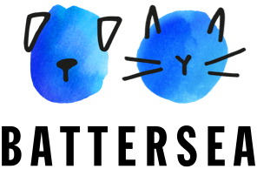  - Share any ideas, suggestions or hopes you have for the future.  If possible, send your letters to them. You might even receive a response!  Task 2  Make a list of as many different types of pet as you can. Can you think of different ways to sort them? For example:  - Pets that have fur and pets that do not have fur.  - Pets that have four legs and pets that do not have four legs.  - Pets that are mammals, pets that are not mammals.  - Pets that are reptiles, pets that are not reptiles.  - Pets that are invertebrates, pets that are not invertebrates.

