Maths  This week the focus for our maths learning is Number & Place Value revision.  Please access via the link below and select Autumn Week 3 for the teaching video to recap on > < and = . There are other videos that may be helpful to complete the activity sheets found on Autumn Week 3 and Autumn Week 4 should you wish to use to help your child understand.  https://whiterosemaths.com/homelearning/year-1/  The activity worksheets can be found on our home learning page.  There is also an additional Extra Miler Challenge  Activity sheet.  Place Value Interactive Game  For a fun activity play basketball place value! Enjoy!  https://www.topmarks.co.uk/learning-to-count/place-value-basketball  One More One Less Interactive Game  For a fun counting activity!  http://www.snappymaths.com/addsub/addsub1w10/interactive/onemoreonelessob/onemoreonelessob.htm  Extra Miler Activities for our Year 1 “Math Professors”  Additional Math activities to support your child’s learning can be found on the BBC Bitesize website.  Select the Karate Cats Maths game. Choose the topic ‘Place Value’  https://www.bbc.co.uk/bitesize/topics/zjkphbk/articles/zf4sscw  Can you work your way through the Bronze, Silver and Gold Levels? |  | English – Read and Respond Week 1  Hairy Maclary from Donaldson’s Dairy by Lynley Dodd  https://www.booktrust.org.uk/books-and-reading/have-some-fun/storybooks-and-games/hairy-maclary/  This week enjoy sharing this classic text with your child! Join Hairy Maclary and friends as they go for a walk around the town. There are lots of discussion, reading and writing opportunities that develop throughout the week, as the children work towards writing their own short story.  Activities for this text can be found on the accompanying ‘Read and Respond’ Unit on the Year 1 Home Learning section of the school website.  Choose a book from your colour band or age group and enjoy reading. You can play the quizzes too!  There are new reading prompts questions added to the home learning page to help you support your child with their reading and comprehension skills.  Reading – Please read daily for at least 10 minutes.  Use the Oxford Owls website and our class login.  https://www.oxfordowl.co.uk/login?active-tab=students  Click on login Students section.  Username: Leaeyear1  Password: year1  Choose 4 – 7 years, click in reading levels and scroll  down to select your child’s book.  Phonics  Can you sort the real words and the fake words? Bob loves eating the real words. His brother Obb loves eating the fake words.  Choose Phase 4 Set 1 – 6 plus 7 and enjoy playing.  Can you try Set 1 – 7 plus consonant diagraphs?  https://www.phonicsplay.co.uk/resources/phase/4/picnic-on-pluto  Spelling Challenge  A fun spelling activity. Can you choose the correct letter order to spell words?  https://www.phonicsbloom.com/uk/game/alien-escape?phase=4  Extra Miler Activities for our Year 1 “English Experts”  https://www.bbc.co.uk/bitesize/topics/zd63xyc/articles/zdp4pg8  Login to the Karate Cats English game on the BBC BItesize website and work your way through the coloured belts as you progress through each stage.
Science  What Are Seasons?  Can you name the four seasons?  Can you name the months of the year? Do you know any events which happen in each of these months?  Make a grid and draw a picture of an event for each month.  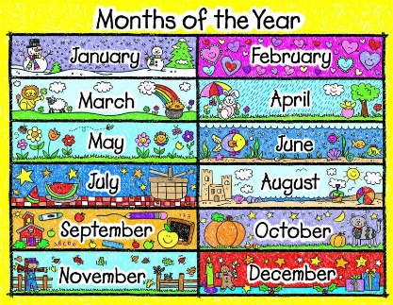  Year 1 Challenge:  What is the weather like this week?  Watch a weather report. Can you spot the symbols the forecaster uses?  Use the weather chart activity grid to record the weather for this week.  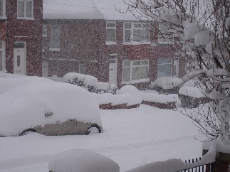 | Music  Round and Round - Happy Bossa Nova Music  https://www.youtube.com/watch?v=D9hCOrGEJ10  Listen to a 3 minute clip of this music.  How does the music make you feel?  Can you think of 5 words to describe the music and write them down?  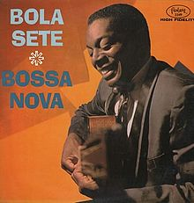  Listen to it again and draw a picture that the music inspires.  Year 1 Challenge  Where does Bossa Nova music come from originally?  Use the SWIGGLE child friendly search engine to research and answer the question.  What instruments can you hear being played?  Draw them and label the instruments. | History  What does the word ‘significant’ mean?  Who are the significant (important) people in your life?  Why are they important?  Write 3 sentences about why that person is important to you.  Who are these significant people? Why are they important?  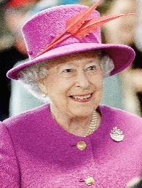  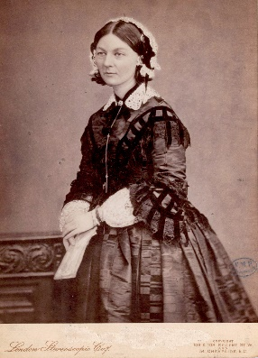  Year 1 Challenge:  Who is this lady?  When did she live?  Can you find out who  she is?  Why is she significant? | R.E  Stories Jesus Heard  I wonder, if Jesus listened to stories when he was little? What stories do you know from the Old Testament? Choose a story and share it with your grown-up.  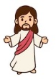  Year 1 Challenge:  Look at the pictures on the RE activity sheet – which stories do they remind you of?  Write the story title next to each picture.  Which is your favourite story?  Draw a picture and retell the story using your best handwriting. Remember your letter formation and to use your lead in and lead out strokes.
Outdoor Learning  Go for a walk outside or at the park. What can you see around you?  What is the weather usually like at this time of year?  Year 1 Challenge:  What season is it now?  Draw a picture or take a photograph of a tree and you dressed in suitable outdoor clothing.  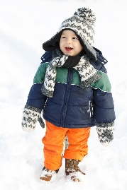  Write a paragraph explaining what has happened to the trees and why you are wearing these clothes. | Computing – Coding  1) If you already have a Home subscription for the Busythings website you can Log in to the Computing section and have a go at the Coding challenges and games.  2) Alternatively, in class we have been working with the Fisher Price Code-a-Pillar toy to explore coding. There is a related free app that you can download for iPads, tablets and phones via Google Play or the Apple Apps store.  This app has levels to work through that will build on the activities your child completed in class last term.  Think & Learn Code-a-Pillar TM  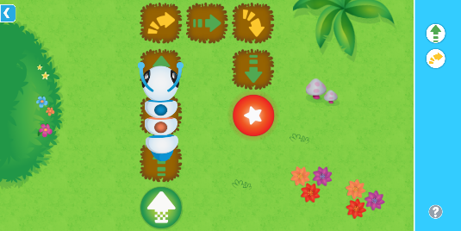 | Design Technology  Flying Machines  What can fly? Can you find items in your home that can fly? Do all the items you have found all fly smoothly? Do they fly quickly? Or slowly? Have you found things that do not fly?  Draw a picture of the things you found and write some words or a sentence to describe how well they flew?  Watch the video clip about the early attempts of air travel. https://www.bbc.co.uk/bitesize/clips/z82xpv4  Can you make a list of the advantages and disadvantages of air travel compared to other forms of transportation? Talk with someone at home about what you noticed on the video clip about how flying machines have changed over time.  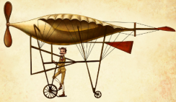  Challenge: Think about how ‘flying machines’ have changed over time. Have they changed shape? Have they changed size? Can you think why have changed over time? | P.S.H.E  Rights and Responsibility  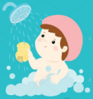  Are there some things that you do every day that you are responsible for doing?  Draw a sequence of pictures that show all the things that you do every day to get ready for school after waking up.  Why do you think it so important that we have daily hygiene routines?  Why it is important to:  - wash hands  - brush teeth  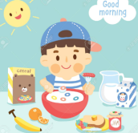  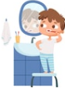  - eat breakfast

Mrs. Ramsay’s Workout of the Week – ROLL THE DICE!
Roll the dice and complete the workout doing the exercises at the side of number. Do each exercise for 30 seconds and then roll the dice again.
Try to do it for 10 minutes (20 rolls), with as little rest as you need. Remember to warm up before you start and cool down at the end.
Do it each day and try to increase the amount of time you can keep going by 2 minutes each day.
Challenge your family to join in and take it in turn to roll the dice. Had fun with this? Why not make up your own ROLL THE DICE exercise challenge?
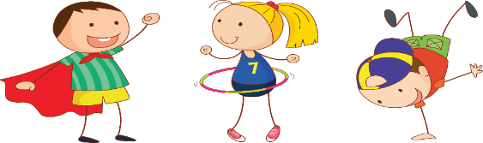

LET’S GET MOVING!
RUN ON THE SPOT
TOUCH YOUR TOES
FROG JUMPS
ARM CIRCLES
STAR JUMPS
DANCE PARTY!

