 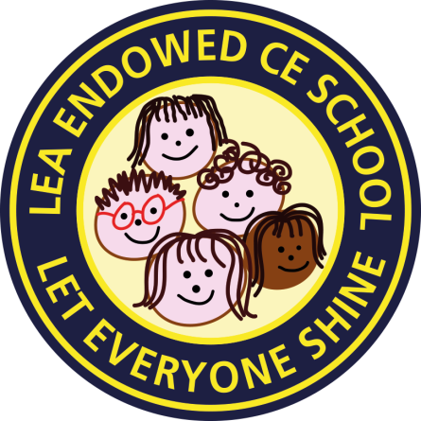





Hello again Year 2,

I hope you are all enjoying the lovely sunshine we have been blessed with and your home learning - although it’s not the same as being in class, is it?

I have been enjoying the sunshine, tidying my garden and keeping an eye on some of my elderly neighbours to make sure they are okay.

I have also been baking and helping my children with their school home learning. High school children get a LOT of homework!!!

What have you been doing? I would love to hear from you and how you are getting on. A new home learning plan will be going up on the school website for you this week. I hope you will enjoy the activities on it but don’t worry if you can only do some of them. You can send me photos and information about your animal projects that you have been working on to our class email.

[class2@leacofe.lancs.sch.uk](mailto:class2@leacofe.lancs.sch.uk)

Remember - Enjoy being with your family, read, relax, remember how special you are! Keep shining your lights brightly!

Sending you all lots of love and hopefully I will see you all very soon.



Mrs Ramsay xxx

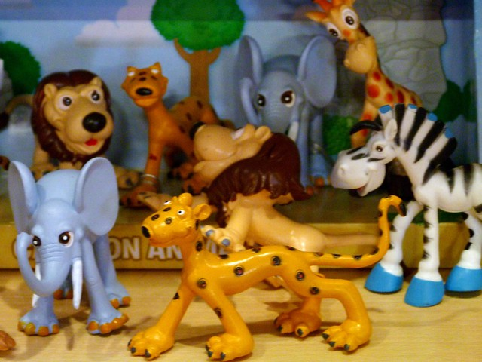

PS: Why not try the Time Capsule activity on our class page that **Ruby** shared with me? 