Maths  This week the focus for our maths learning is Place Value  There are lots of wonderful resources on the White Rose Hub for you to access to support your child’s home learning.  https://whiterosemaths.com/homelearning/year-1/week-12-number-place-value-within-20/  You can access the teaching videos via the link below. Please access the related worksheets on our school website in the Home Learning section.  Try to complete one video and the related activity every day. Sessions 1,2 & 3.  Place Value Interactive Game  For a fun activity play basketball place value! Have fun!  https://www.topmarks.co.uk/learning-to-count/place-value-basketball  Extra Miler Activities for our Year 1 “Math Professors”  Additional Math activities to support your child’s learning can be found on the BBC Bitesize website.  Select the Karate Cats Maths game. Choose the topic ‘Place Value’  https://www.bbc.co.uk/bitesize/topics/zjkphbk/articles/zf4sscw  Can you work your way through the Bronze, Silver and Gold Levels? |  | English  Reading – Read daily via the Oxford Owls website using our class login.  https://www.oxfordowl.co.uk/login?active-tab=students  Go to the Oxford Owl for Schools and click on login.  Students section.  Username: Leaeyear1  Password: year1  Choose 4 – 7 years, click in reading levels and scroll down to select your child’s book.  Choose a book from your colour band or age group and enjoy reading. You can play the quizzes too!  There are new reading prompts questions added to the home learning page to help you support your child with their reading and comprehension skills.  Phonics  Can you sort the real words and the fake words? Bob loves eating the real words. His brother Obb loves eating the fake words.  Choose Phase 4 Set 1 – 6 plus 7 and enjoy playing.  Can you try Set 1 – 7 plus consonant diagraphs?  https://www.phonicsplay.co.uk/resources/phase/4/picnic-on-pluto  Spelling Challenge  A fun spelling activity. Can you choose the correct letter order to spell words?  https://www.phonicsbloom.com/uk/game/alien-escape?phase=4  Extra Miler Activities for our Year 1 “English Experts”  https://www.bbc.co.uk/bitesize/topics/zd63xyc/articles/zdp4pg8  Login to the Karate Cats English game on the BBC BItesize website and work your way through the coloured belts as you progress through each stage.
Frosty Fingers  Investigate what happens when you leave an ice cube or an ice-lolly on a plate.  Explore and see what happens if you put them in different places around the house. Write about what you discovered. | Snowflakes  How many different snowflake patterns can you make from different shaped pieces of paper? | Do you wanna build a Snowman?  Construct a snowman using cotton wool or other items you find at home?  How many different materials can you use?  Can you write a list of the material you used? | New Year’s Resolution  Make a poster of your New Year’s resolutions.  Can you decorate your poster?  Are your New Year resolutions the same as anyone else in your family?
Winter Walk  Go on a walk and collect natural materials/objects to make a collage picture or make a sculpture outside and take a photograph.  Send it in – we’d love to see your creations! | Instruction writing  Write a set of instructions for something you have made this week at home.  Eg. Snowflakes  Collage  Snowman  Baking/Cooking | My Favourite Christmas Present  What did Santa bring you?  Draw a picture of your favourite Christmas present and write about why you like it so much.  Can you use the word ‘and’ to write longer sentences? | Little Snowflake  Listen to the song Little Snowflake by Super Simple Songs  https://www.youtube.com/watch?v=tbbKjDjMDok  Can you sing along and make a snowflake dance?  Write a list of as many words as you can to describe a snowflake.  Can you write the words that rhymed together?

Workout of the Week – SPELL OUT YOUR NAME!
Using all the letters of your name (no cheating – must be your FULL first name and surname!) complete the workout doing the exercises at the side of each letter with the specified number of repetitions. Try to do it as quickly as possible, with as little rest as you need, BUT be careful not to get too excited and hurt yourself or others. Remember to warm up before you start and cool down at the end.
Do it each day and try to beat your time. Challenge your family to do their name exercises as well. Enjoy!!!
Had fun with this? Why not make up your own SPELL OUT YOUR NAME exercise challenge?
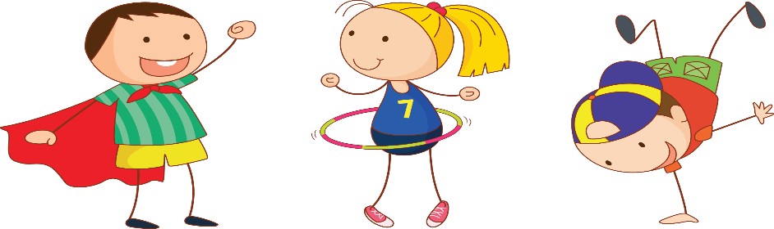

A : 10 HOPS | N: 10 BUNNY HOPS
B : 10 BUNNY HOPS | O: 20 HOPS
C: 10 SKIPS | P: 15 STAR JUMPS
D: 15 STAR JUMPS | Q: COMMANDO CRAWL FOR 10 SECS
E: 5 TUCK JUMPS | R: 10 SKIPS
F: MARCH ON THE SPOT FOR 30 SECS | S: BALANCE A TEDDY ON YOUR RAISED KNEE FOR 10 SECS
G: DO A SILLY DANCE FOR 30 SECS – CHALLENGE MUM! | T: 10 TUCK JUMPS
H: RUN ON THE SPOT FOR 10 SECS | U: BOUNCE A BALL FOR 15 TIMES
I: BOUNCE A BALL 10 TIMES | V: JOG ON THE SPOT FOR 30 SECS
J: BALANCE A TEDDY ON YOUR HEAD (20 SECS) | W: BALANCE ON EACH FOOT FOR 10 SECS
K: BALANCE ON 1 FOOT FOR 10 SECS | X: 15 STAR JUMPS
L: HOP, SKIP AND JUMP 3 TIMES | Y: DO A SILLY DANCE FOR 30 SECS – CHALLENGE DAD!
M: MOVE LIKE YOUR FAVOURITE ANIMAL FOR 30 SECS | Z: 5 TUCK JUMPS

