Maths  This week the focus for our Maths learning is Addition and Subtraction within 20.  Please access via the link below and select for the teaching video for adding by counting on.  https://whiterosemaths.com/homelearning/year-1/spring-week-3/  The activity worksheets can be found on our home learning page.  There is also an additional Extra Miler Challenge  Activity sheet.  Place Value Interactive Game  Can you use your knowledge of place value to order these numbers?  https://www.ictgames.com/mobilePage/countingCaterpillar/index.htm  l  Play Your Cards Right Interactive Game  For a fun activity to order numbers – ‘higher’ or ‘lower’  https://www.ictgames.com/mobilePage/playYourCardsRight/index.html  Extra Miler Activities for our Year 1 “Math Professors”  Additional Math activities to support your child’s learning can be found on the BBC Bitesize website.  Select the Karate Cats Maths game. Choose the topic ‘Place Value’  https://www.bbc.co.uk/bitesize/topics/zjkphbk/articles/zf4sscw  Can you work your way through the Bronze, Silver and Gold Levels? |  |  | English  The Highway Rat by Julia Donaldson  Meet the greedy Highway Rat, but beware! He is determined to steal from anyone who dares to cross his path on the highway!  There are lots of ideas for writing activities on the accompanying ‘Read and Respond’ Unit on the Year 1 Home Learning section of the school website.  ‘English Y1 ‘The Highway Rat’.  Reading – Please read daily for at least 10 minutes.  Use the Oxford Owls website and our class login.  https://www.oxfordowl.co.uk/login?active-tab=students  The site is experiencing a lot of traffic at the moment but is  working hard to make it accessible to all.  Username: Leaeyear1 Password: year1  Phonics  Choose a set of sounds to practice – Phase 3 or Phase 5 if you want a challenge.  Wait for the pencil to write the grapheme. You can press the sound button to hear the phoneme. Then press on the '...' at the bottom of the card to see the grapheme in the words.  Can you read the words? If you need help, press on the dots and dashes to blend the sounds.  'Kiss goodbye' to the words when you have read them.  http://www.ictgames.com/mobilePage/soundSayer/index.html  Spelling Challenge  A fun spelling activity. Can you choose the correct letter order to spell words?  https://www.phonicsbloom.com/uk/game/alien-escape?phase=4  Extra Miler Activities for our Year 1 “English Experts”  https://www.bbc.co.uk/bitesize/topics/zd63xyc/articles/zdp4pg8  Login to the Karate Cats English game on the BBC BItesize website and work your way through the coloured belts as you progress through each stage.
Science  Winter Weather  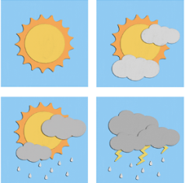  This week we are observing weather in winter.  We are going to make our own weather report by collecting and recording the weather for a week.  Use the ‘Science Weather Recording’ worksheet to observe the weather for one week in the morning and afternoon. You can draw pictures and label your pictures.  What did you find out?  Year 1 Challenge  Can you make a rain gauge?  Use the information sheet ‘Make a rain gauge’ and record the amount of rainfall for one week.  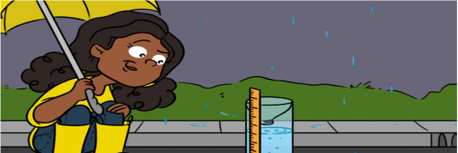 |  | Music  I wanna play in a band!  This week we are making our own music.  How many more instruments can you make to go with your shakers and guitars?  How about making a drum from a strong box, a large container, or a tin?  Can you make any other instruments?  Send in your photos – we would love to see them!  Listen to the music and play along with your instruments.  https://www.youtube.com/watch?v=D9hCOrGEJ10  Year 1 Challenge:  Write a verse to add to our song ‘I wanna play in a band’.  Eg.  I wanna play a guitar,  I wanna play a …  I wanna play a …  I wanna play a….  Can you play your instrument and sing?  Send in a video |  | History  Mary Seacole  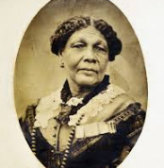  Look at the Mary Seacole Power Point and read it with an adult.  Use your knowledge to play the Mary Seacole game. Instructions and board game sheets are on the home learning page.  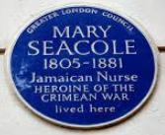  Have fun!!  Year 1 Challenge  Create a fact file about Mary.  You can make a little booklet by folding a piece of paper and write 1 fact on each page  When was she born?  Where was she born?  Where did she grow up?  What special skills did she have?  What did she do that makes her significant?  How did Mary help the soldiers in the Crimea?  Why is Mary Seacole such a wonderful role model for us? |  | R.E  Stories Jesus Heard  If you have a bible, read and share the bible story about ‘Daniel in the Lion’s Den.’  Or watch this short video clip of the story.  https://www.youtube.com/watch?v=bEM_X25DWPk  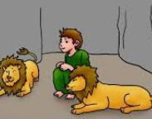  Daniel grew up in Babylon and served King Darius. He worked hard. He loved God and prayed to him every day.  Daniel put his trust in God.  How did God help him?  Make a Daniel and a lion puppet and retell the story in your own words.  Year 1 Challenge  Daniel was very brave.  Can you think of a time when you have been brave? Draw a picture and write about how you were brave.  What/Who helped you to be brave?
Outdoor Learning  Go for a walk outside, in your garden or at the park.  What can you see around you?  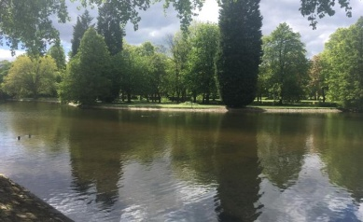  Can you see any changes taking place with the plants or trees since last week?  Are any plants starting to grow?  Has the very wet weather changed things? How?  Take pictures of any new growth, changes or animals that you spot this week and send them in. | Computing – Coding  Do you have a remote control or programmable toy?  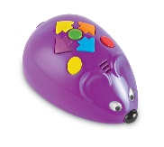  Make a maze or obstacle course for your toy to navigate.  How will your toy get from the start to the finish point? Experiment and see if you can get to the end of the maze.  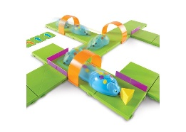  Challenge:  Draw a map of your maze and write a list of the actions your toy had to follow to get to the end in your Lockdown Learning book.  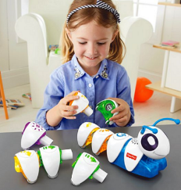 |  | 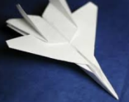  Design Technology  Flying Machines  Did you make a paper airplane? Did it fly?  Do you think you can make an airplane that flies quicker? Or make an airplane that flies further?  Can you make a change to your design from last week? Maybe change the material, shape or size?  Make 2 different airplanes and test them to find out what can make an airplane fly quicker or furthest. (Use the PowerPoint in the Home Learning ‘Worksheets’ to help you)  Did you enjoy watching the Story Bots Song about lift, weight, thrust, drag  https://www.youtube.com/watch?v=6V0WeETNIFY  Can you explain to an adult how lift, weight, thrust and drag have helped your airplanes to fly?  Have fun flying your airplanes!  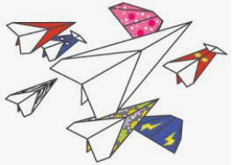 |  | P.S.H.E  Rights and Responsibility  Taking care of something  - What needs do we all share? Do we need to eat? Drink water? Can you think of more needs?  - Who is responsible for meeting our needs?  - Does everyone in your family have the same needs?  - Would rules help us to be responsible for other people’s needs?  - Do you help with anyone’s needs at home?  Watch 'The Pigeon Wants a Puppy' by Mo Willems about looking after things. https://www.youtube.com/watch?v=HiR1zuofXqw  Can you make a list of what a puppy needs to be properly looked after?  Year 1 Challenge  Can you write a list of jobs that will meet those needs?  Are you responsible for anyone else’s needs?
